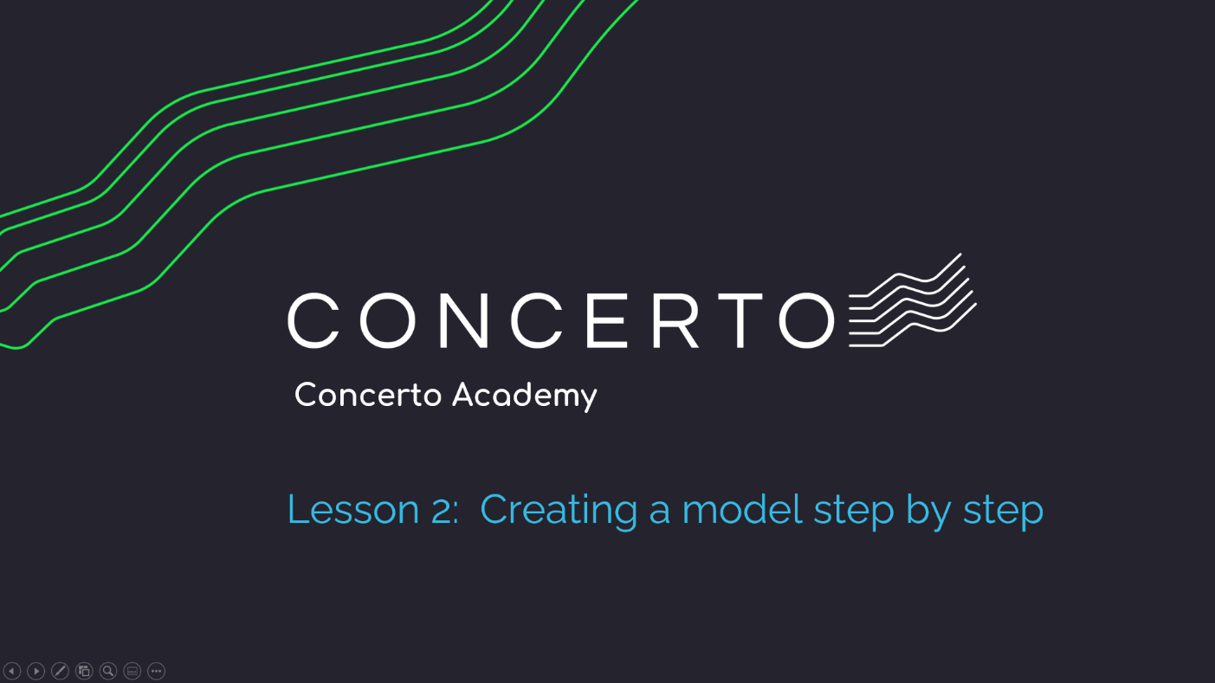

Table of Contents
Introduction 5
Concerto Academy Overview 5
Lesson 2: Creating a model step by step 7
Overview 7
Lesson Objectives 7
Part 1: Creating a document 8
Video 8
Step by Step 8
Part 2: Creating a model step by step 11
Video 11
Step by Step 12
Part 3: Adding data to your model 21
Video 21
Attachments 21
Step by Step 22

Introduction

Concerto Academy Overview
The Concerto Academy is designed to cover Concerto basics and provide simple step-by-step exercises to get you going fast.

Concerto Academy lessons cover the following:

- Concerto Overview & Case Study

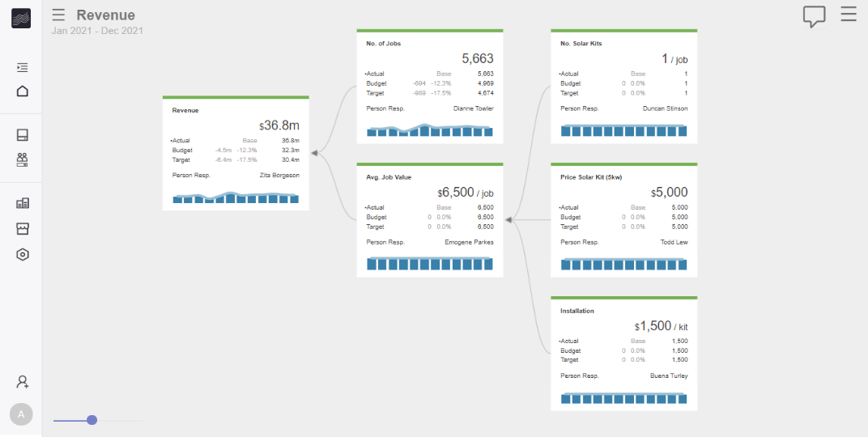
- Creating a model step by step
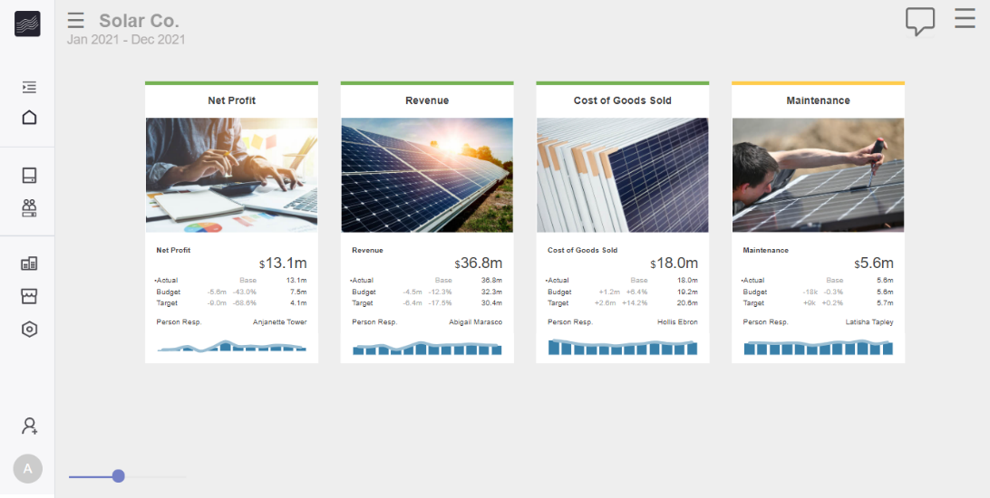
- Creating a scorecard step by step
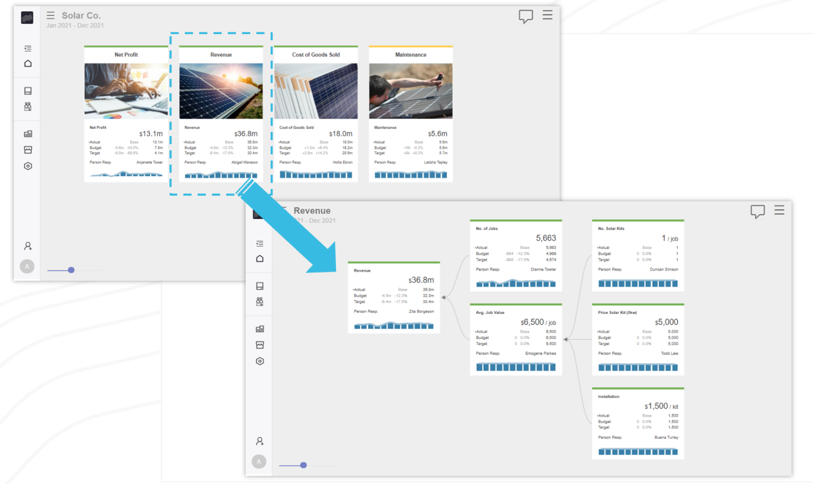
- Linking scorecards and models

Lesson 2: Creating a model step by step

Overview

Lesson Objectives
This lesson covers creating a simple model step-by-step.
- Part 1: Creating a document
- Part 2: Creating a model step by step
- Part 3: Adding data to your model

Lesson Outcome
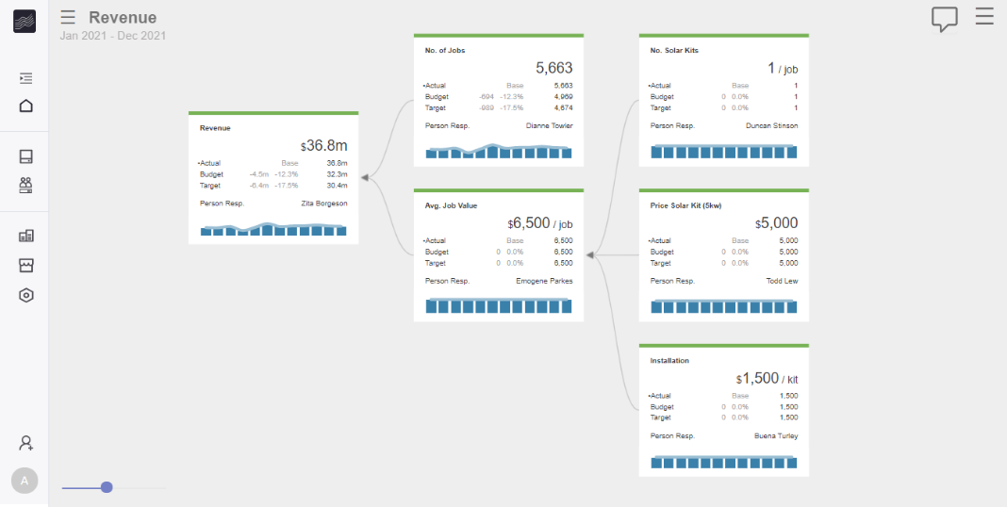
Creation of the Revenue model below.

Part 1: Creating a document

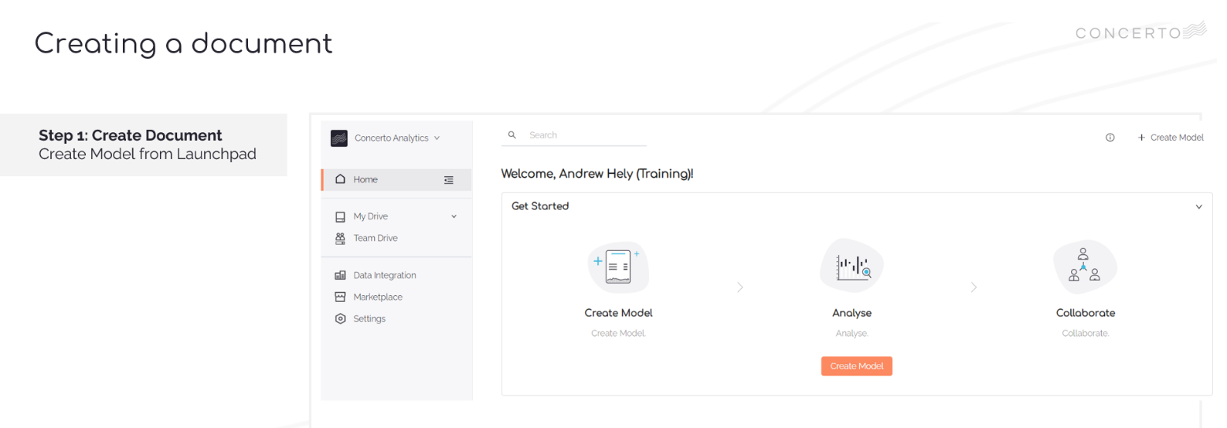
Video

- VIDEO: Lesson 2 – Creating a model step by step
- TIMESTAMP: 0.09

Step by Step
Step 1 | Creating a Document
Step 1a | Click Create Model from the launchpad 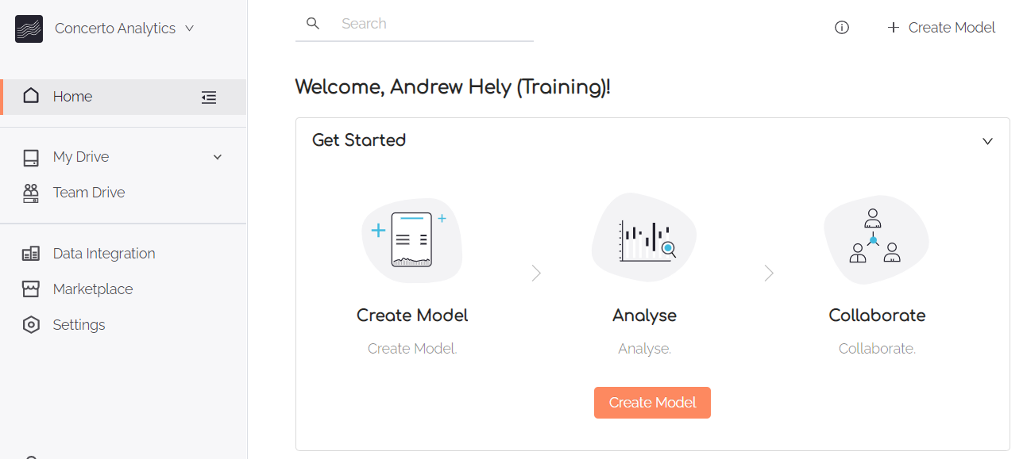
Step 1b | Click Blank Document to continue  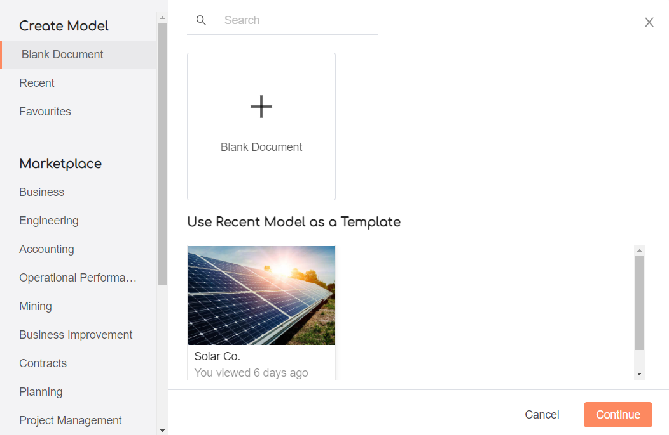
Step 1c | Name your document My Solar Co  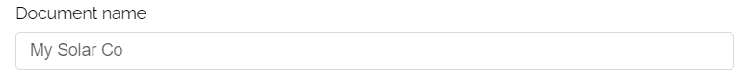
Step 1d | Select an image Thumbnail for your document  - Click Select Image  - Navigate to My Drive > Training > Images  - Select Image 02 Revenue.jpg  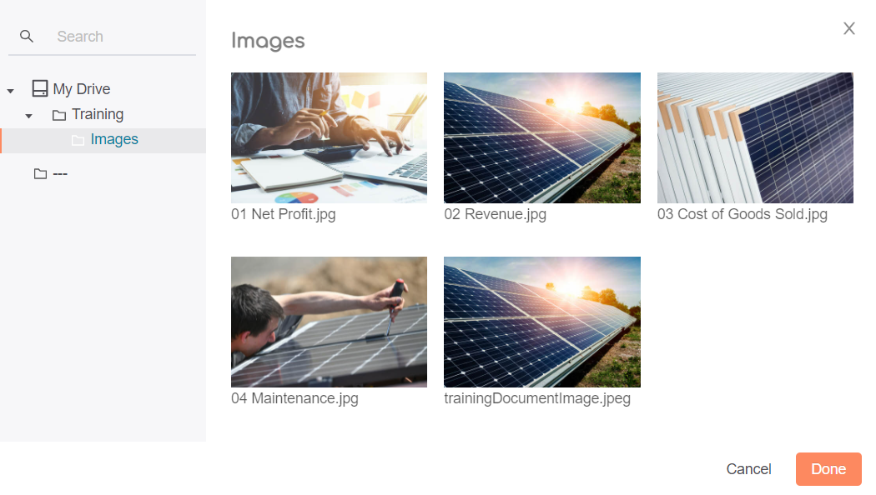
Step 1e | Click Create Document  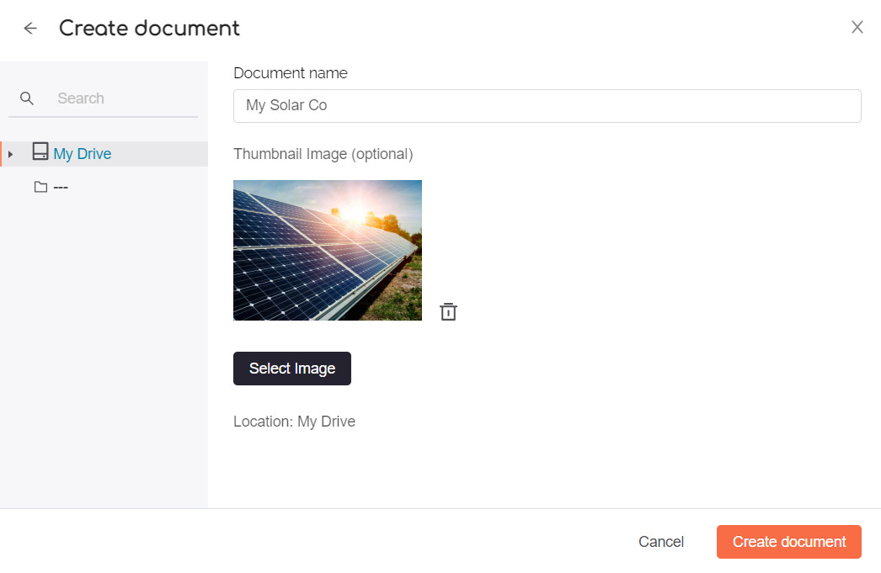

Part 2: Creating a model step by step

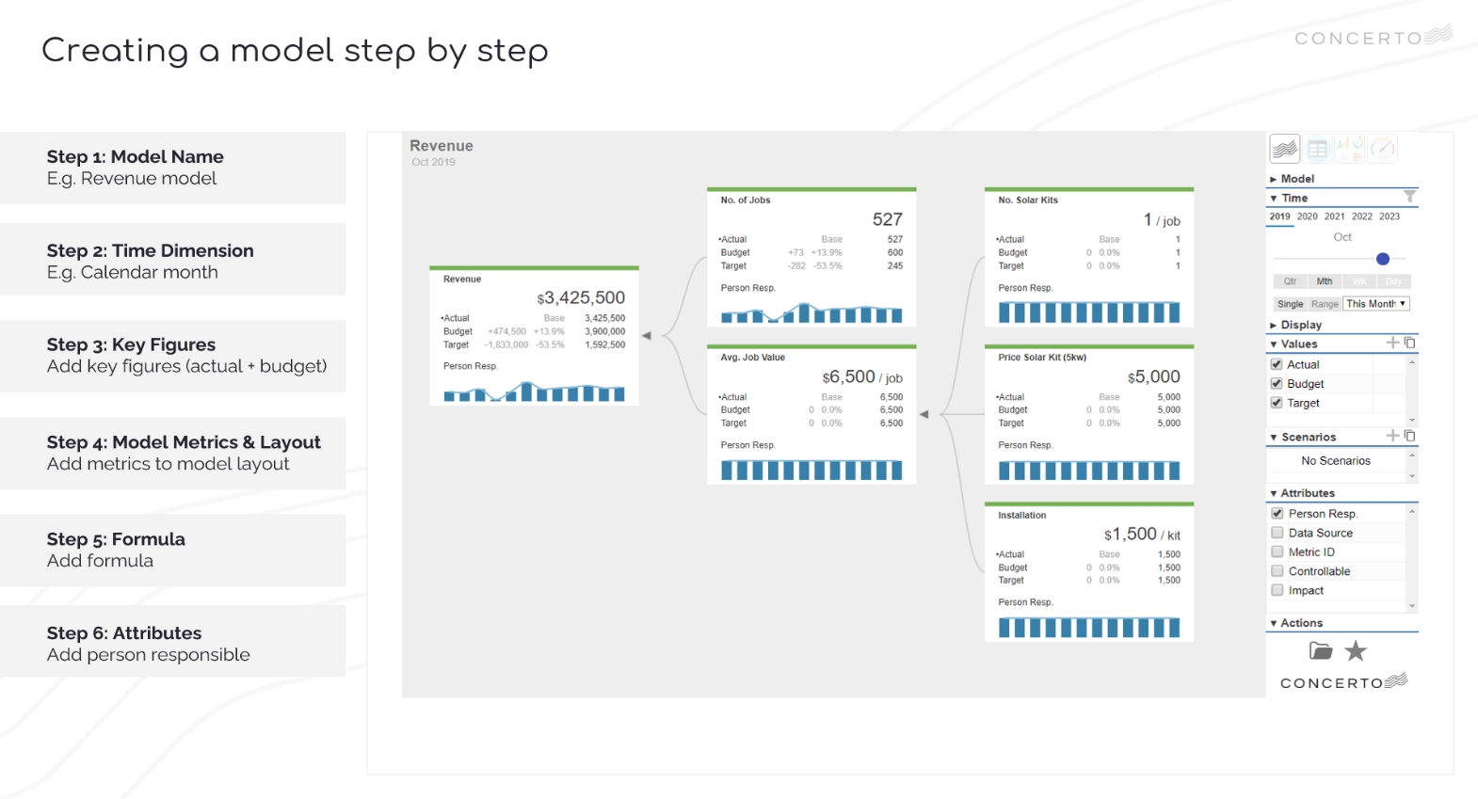
Video
- VIDEO: Lesson 2 – Creating a model step by step
- VIDEO TIMESTAMP: 0.38

Step by Step
Step 1 | Model Name  Click Create Now to create your first model  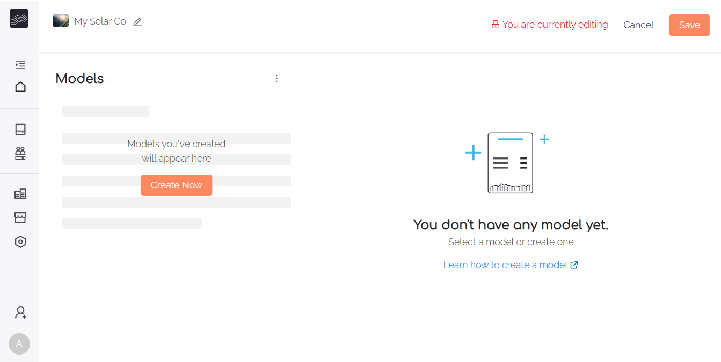  Set Model Name: Revenue  Set Model Type: Value Model  Click Create  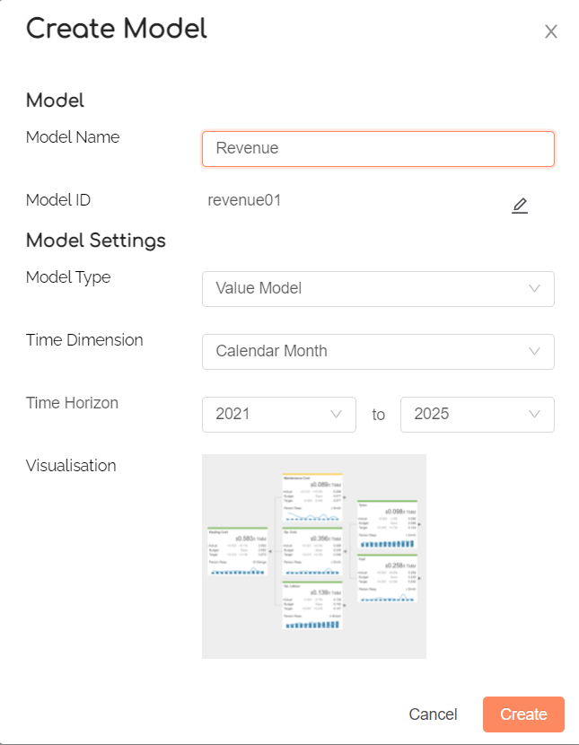
Step 2 | Time Dimension  Check Time Dimension is set to Calendar Month  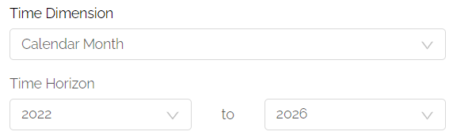
Step 3 | Key Figures  Check Key Figure settings are as shown below  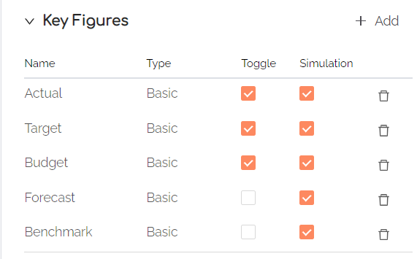  Check Toolbar Tile & Spark settings are as shown below:  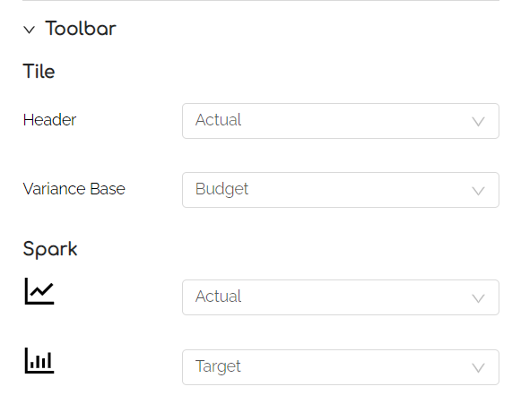  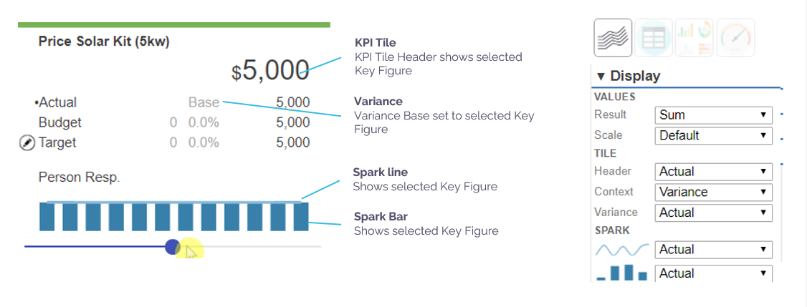

Step 4 | Model Metrics & Layout  The following steps cover adding Revenue model metrics step by step.  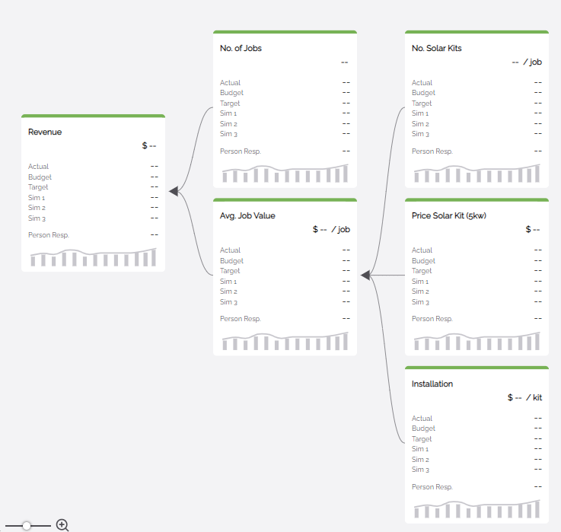
Step 4a | Edit Revenue  Click the pencil icon, to edit Revenue Metric properties  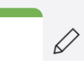  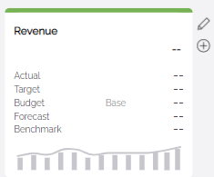  Set Revenue properties to below and save  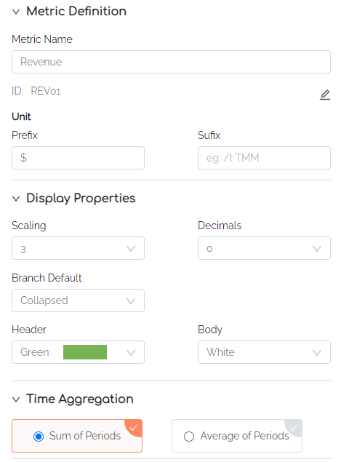
Step 4b | Add No Jobs  Add No Jobs under Revenue using + button  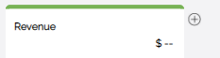  Set properties as shown  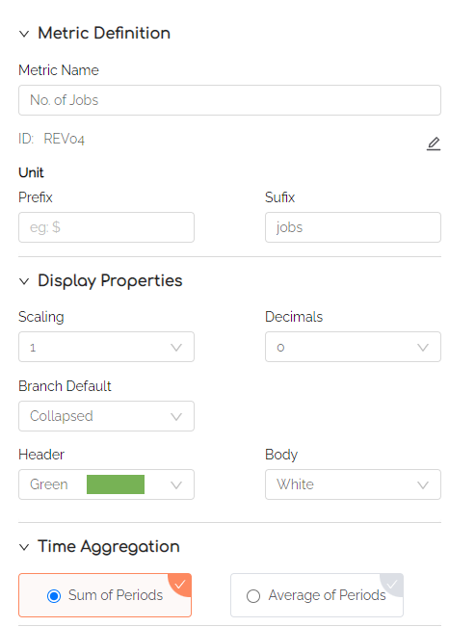
Step 4c | Add Avg Job Value  Add Avg Job Value under Revenue using + button  Set properties as shown  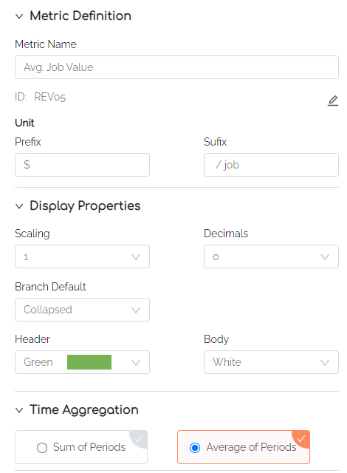
Step 4d | Add No Solar Kits  Add No Solar Kits under Avg Job Value using + button  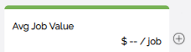  Set properties as shown  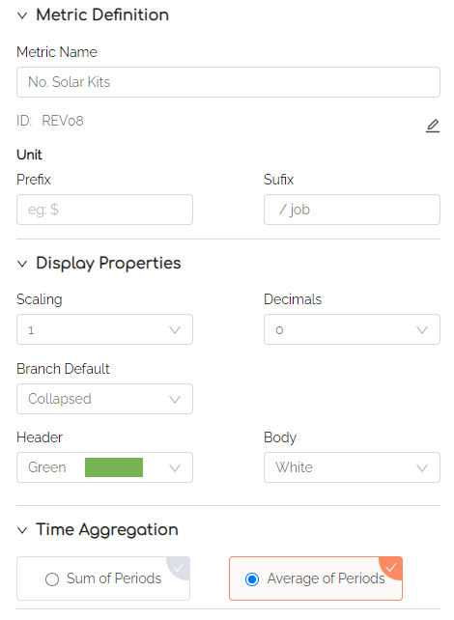
Step 4e | Add Price Solar Kit (5kw)  Add Price Solar Kit (5kw) under Avg Job Value using + button  Set properties as shown  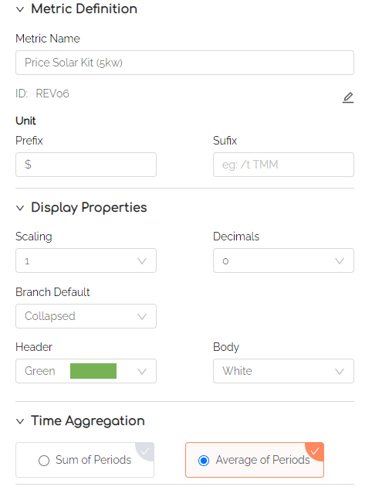

Step 4f | Add Installation  Add Installation under Avg Job Value using + button  Set properties as shown  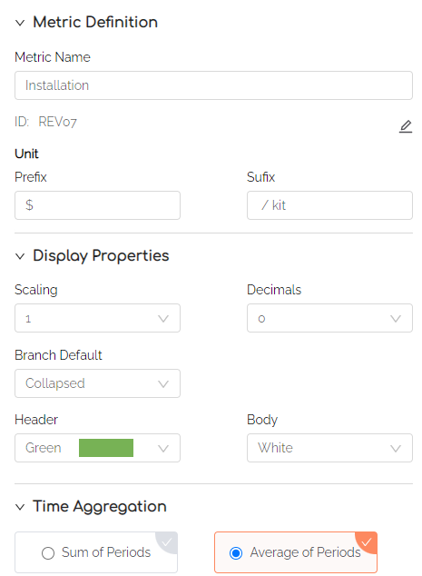
Step 5 | Formula  Add the following formula for Average Job Value 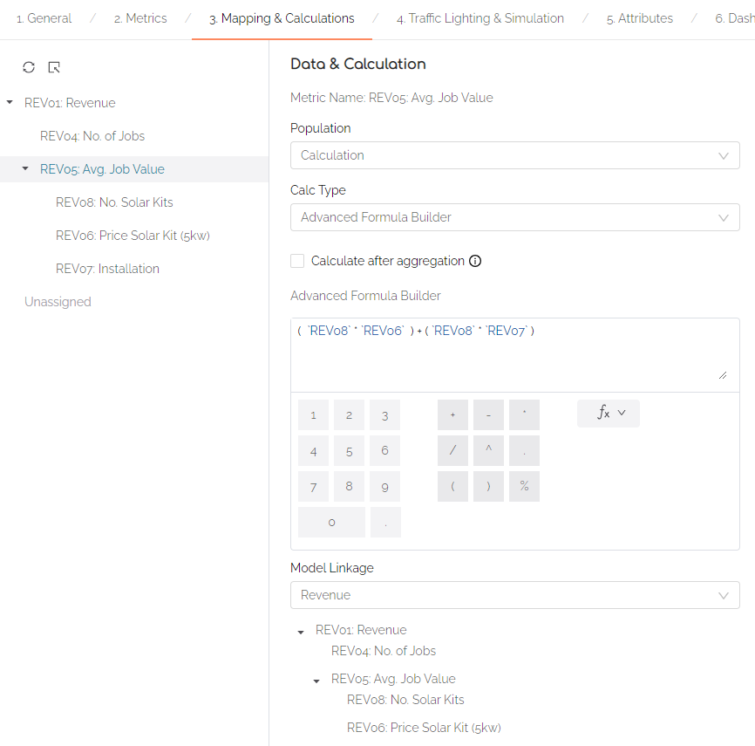  Add the following formula for Revenue  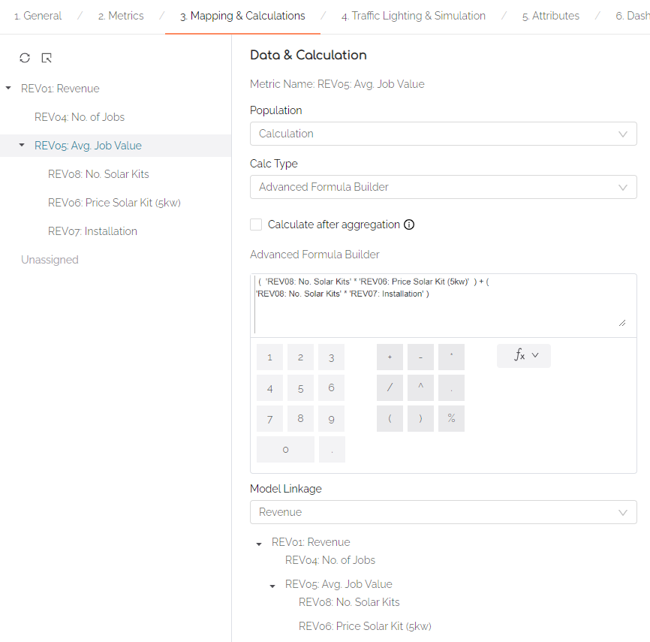
Step 6 | Attributes  Create Person Resp as an attribute, and add a name of person responsible for each metric  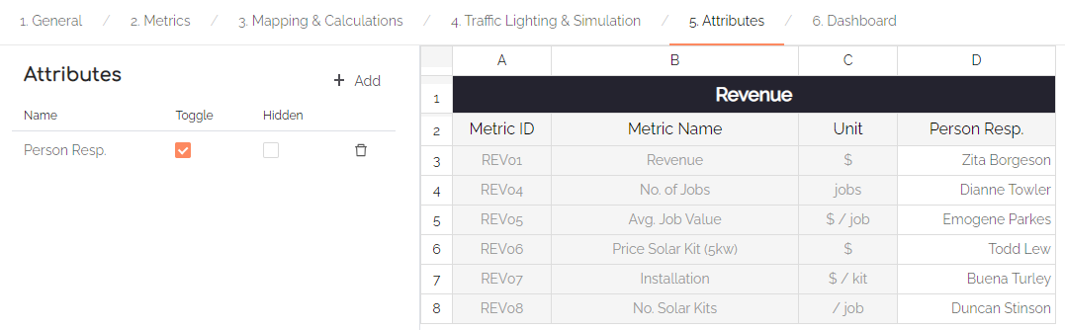
Save | Save and View your model  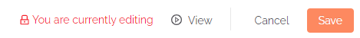  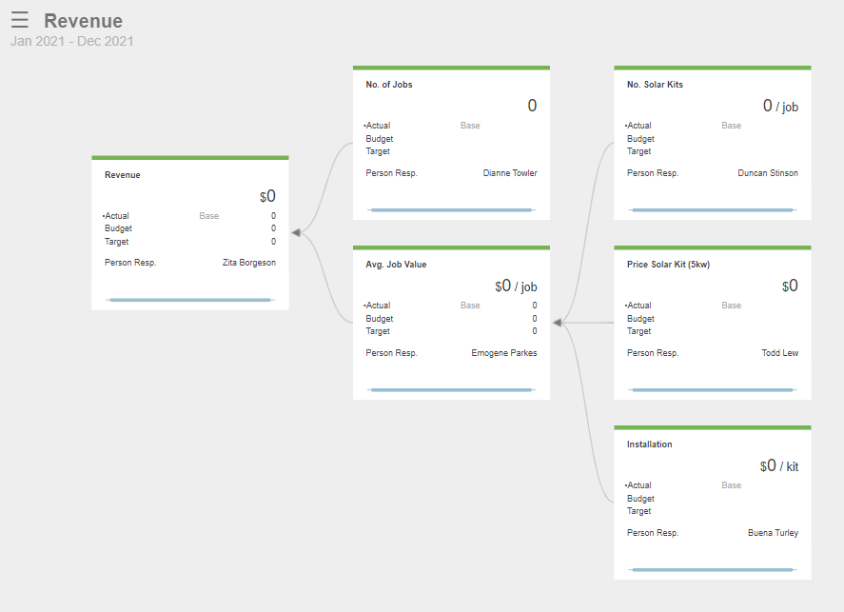  TIP: In Part 3 you’ll add data to your model.

Part 3: Adding data to your model

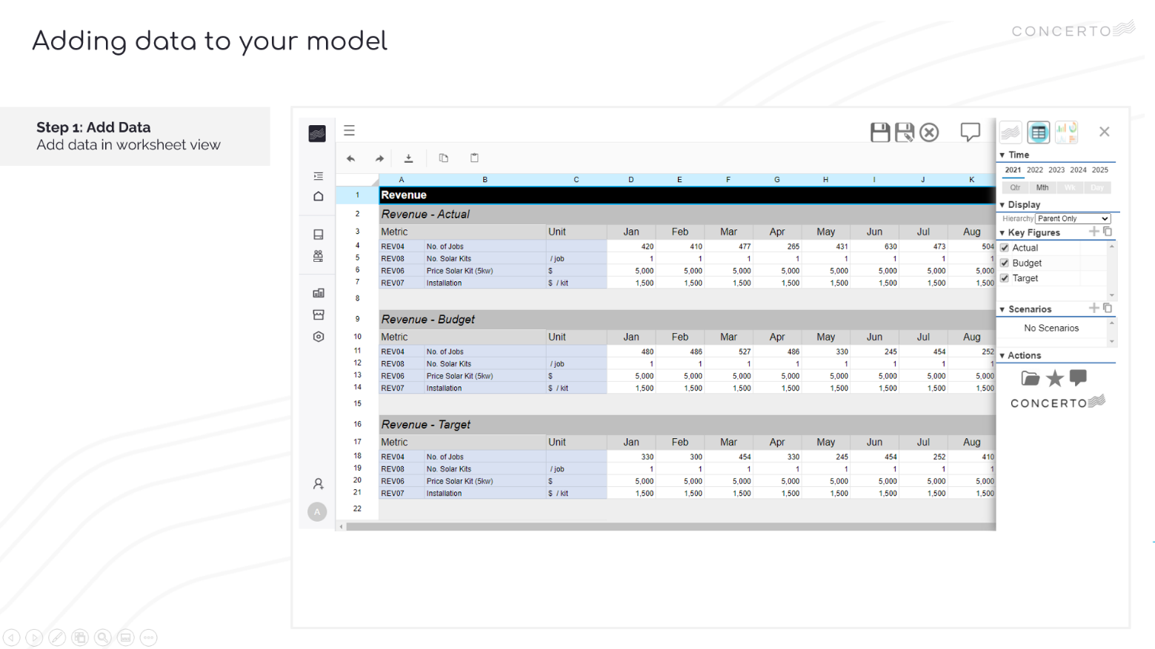
Video

- VIDEO: Lesson 2 – Creating a model step by step
- TIMESTAMP: 3.56

Attachments
- Revenue Data.xls
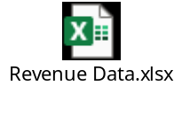

Step by Step
Step 1 | Adding & saving data
Step 1a | Go to Worksheet view  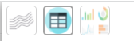  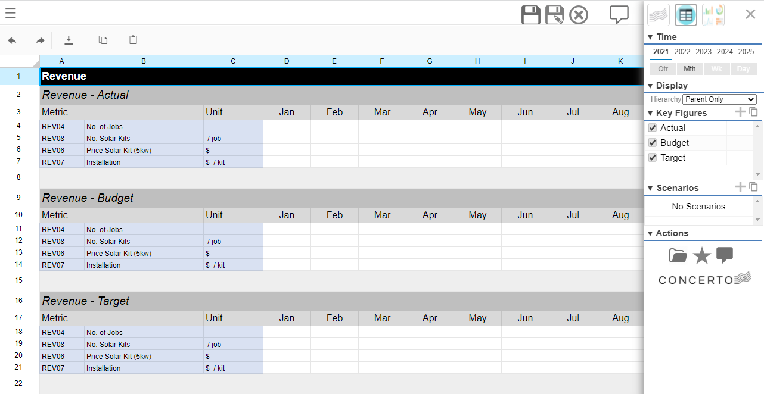
Step 1b | Open Attachment Revenue Data.xls
Step 1c | Copy & Paste revenue data for Actual, Budget, Target key figures  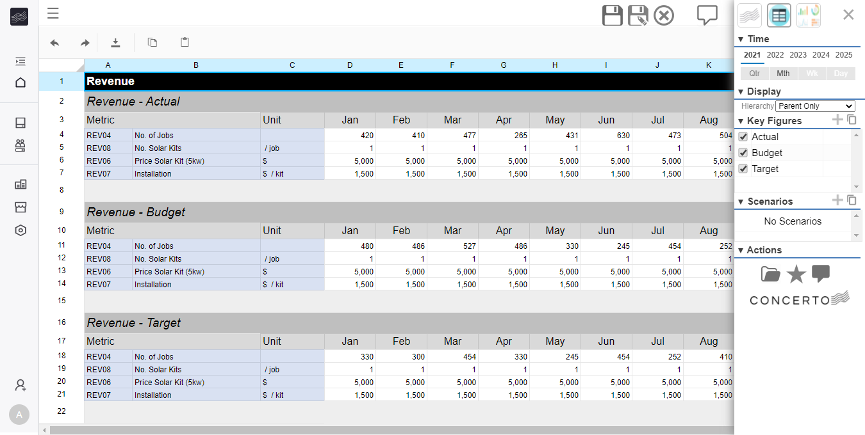
Step 1d | View your data in Concerto view  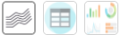  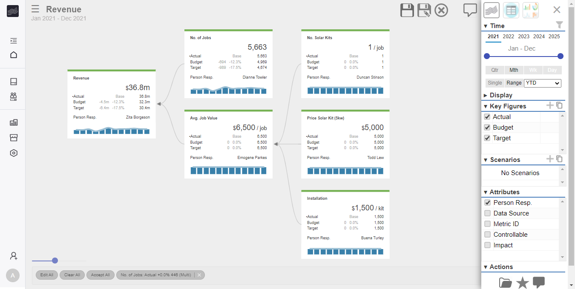
Save | Save your data  