

Table of Contents

Lesson 3: Creating a dashboard step by step 5
Overview 5
Lesson Objectives 5
Lesson Outcome 5
Part 1: Creating an aggregated dashboard 6
Video 6
Step by Step 6
Part 2: Creating a timeseries dashboard 15
Video 15
Step by Step 15

Lesson 3: Creating a dashboard step by step

Overview

Lesson Objectives
This lesson covers creating a dashboard step-by-step.
- Part 1: Creating an aggregated dashboard
- Part 2: Creating a timeseries dashboard

Lesson Outcome
Creation of an aggregated dashboard and a timeseries dashboard for the Revenue model created in lesson 2.
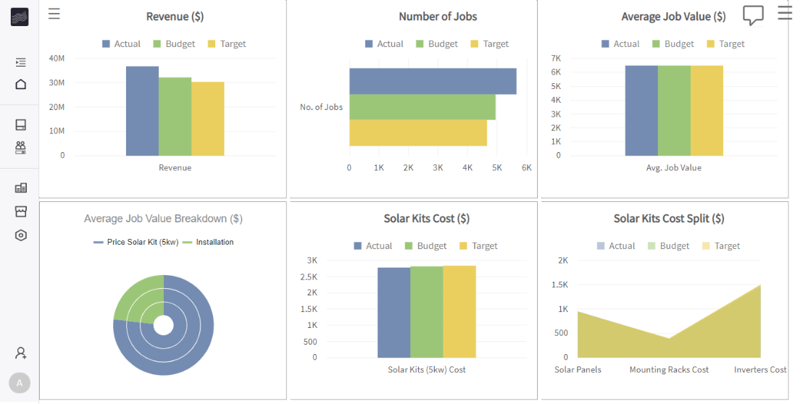
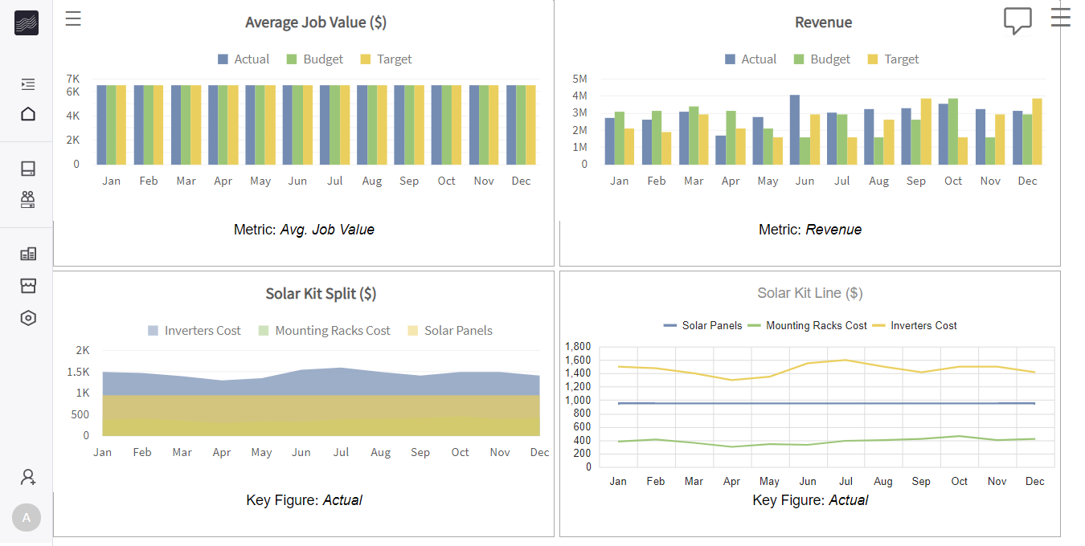

Part 1: Creating an aggregated dashboard

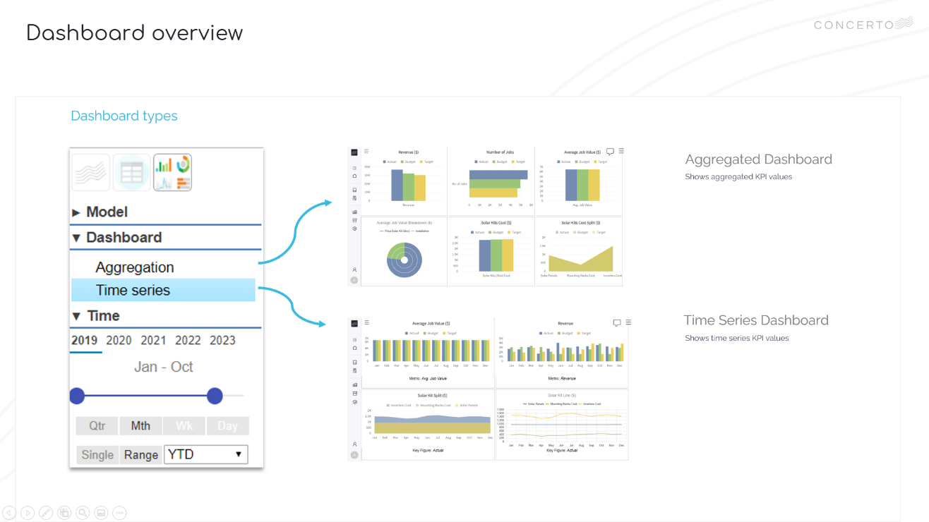
Video

- VIDEO: Lesson 3 – Creating a dashboard step by step
- TIMESTAMP: 0.22

Step by Step
Step 1 | Create and Customise Dashboard Charts
Step 1a | From the launchpad, right-click your My Solar Document to Edit Model  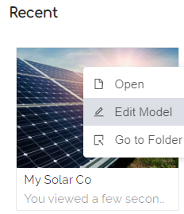  Select the Revenue model  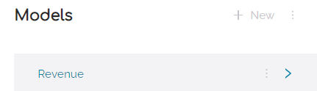  Go to the dashboard tab  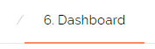
Step 1b | Add Revenue chart under the Aggregation Dashboard  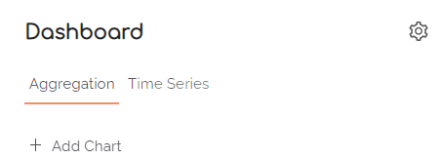  Customise Revenue ($) chart as shown and save  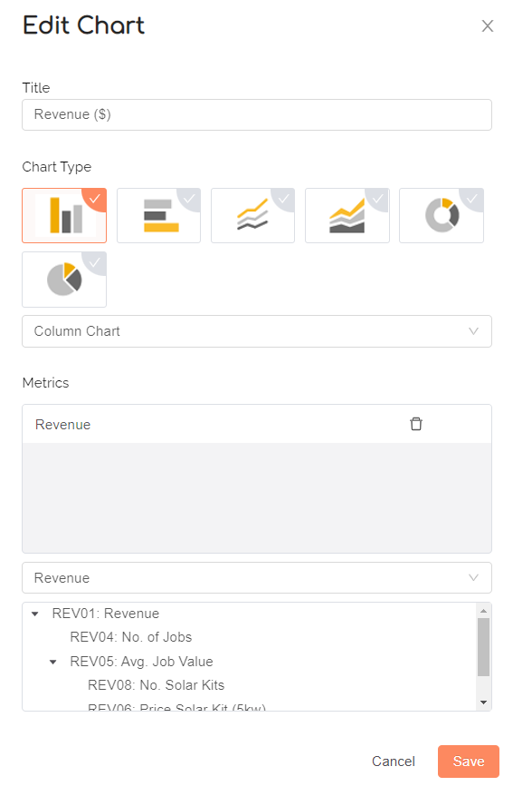
Step 1c | Add and customise No of Jobs chart as shown and save  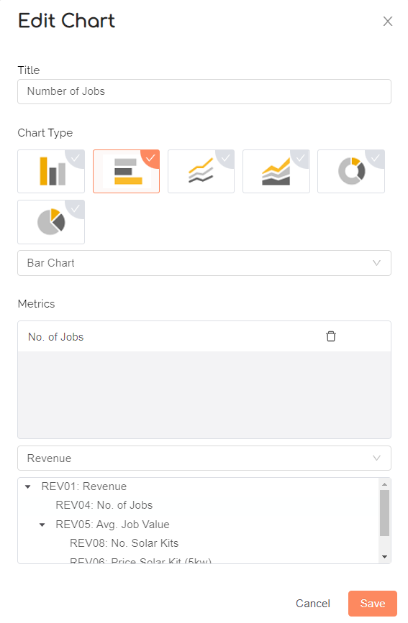
Step 1d | Add and customise Average Job Value ($) chart as shown and save  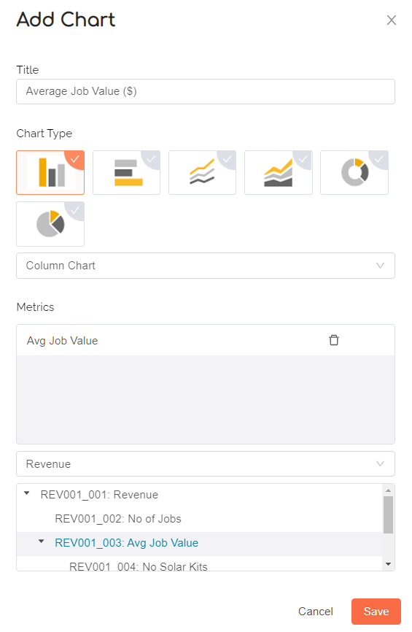
Step 1e | Add and customise Average Job Value Breakdown ($) chart as shown and save  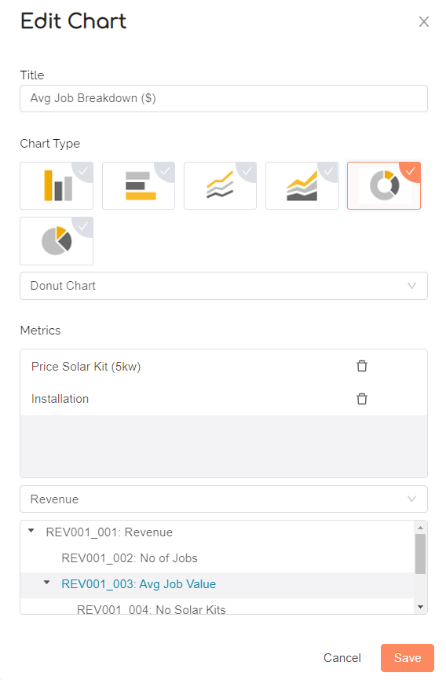
Step 1f | Add and customise Solar Kits Cost ($) chart as shown and save  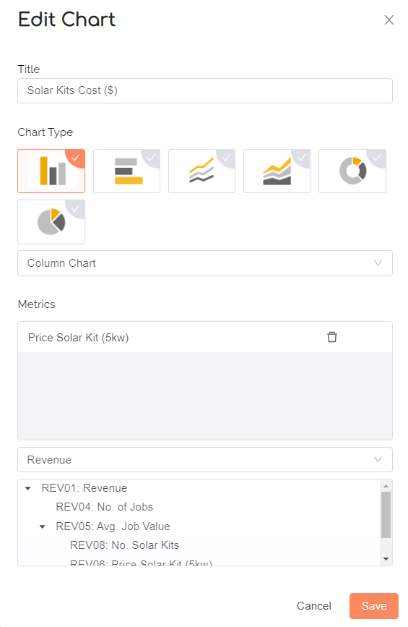
Step 1f | Add and customise Solar Kits Cost Spit ($) chart as shown and save  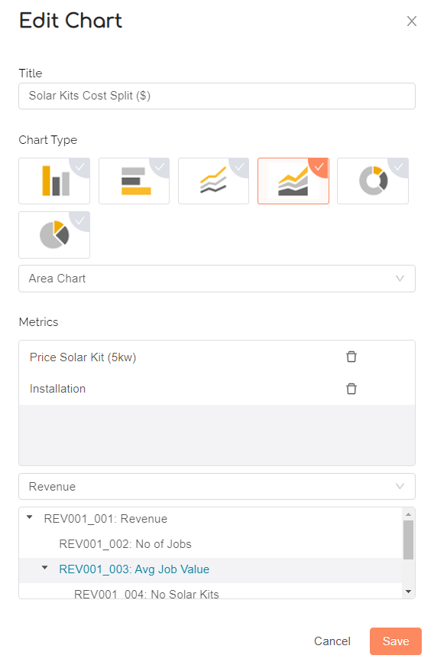
TIPS | TIP: You can use the settings icon to control number of dashboard tiles per row  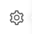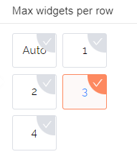  TIP: You can choose metrics from another model using the model dropdown
Save | Save and view your dashboard    Switch to Dashboard View to see your aggregated dashboard  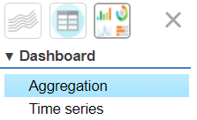

Part 2: Creating a timeseries dashboard

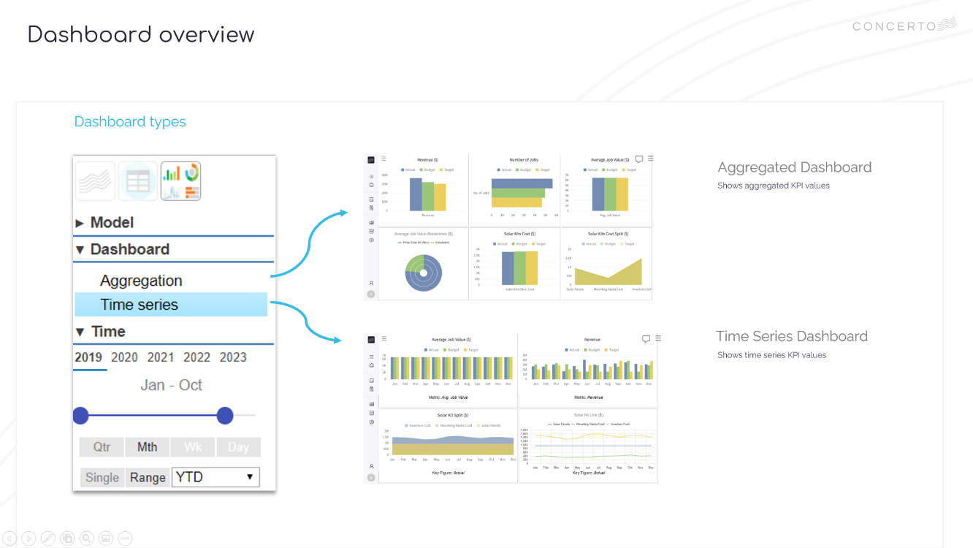
Video

- VIDEO: Lesson 3 – Creating a dashboard step by step
- TIMESTAMP: 2.28

Step by Step
Step 1 | Create and Customise Dashboard Charts
Step 1a | From the launchpad, right-click your My Solar Document to Edit Model  Go to the dashboard tab
Step 1b | Add Average Job Value ($) chart under the Timeseries Dashboard  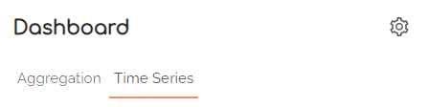  Average Job Value ($) chart as shown and save  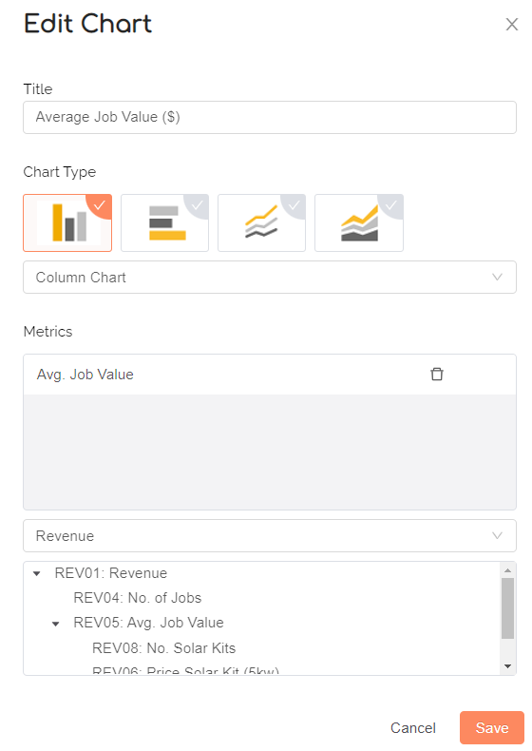
Step 1c | Add and customise Revenue ($) chart as shown and save  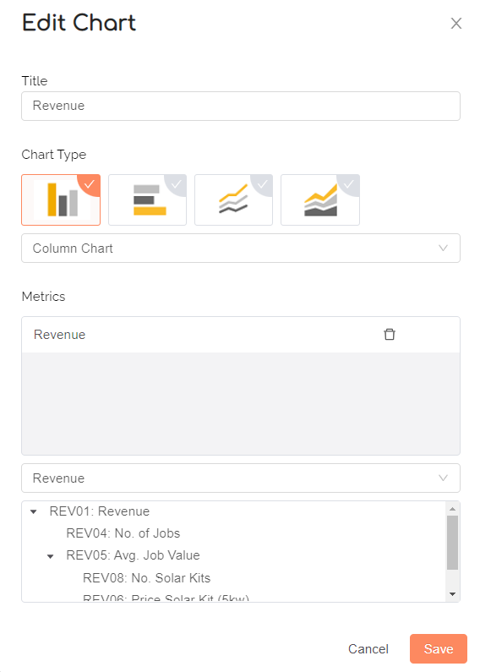
Step 1d | Add and customise Number of Jobs chart as shown and save  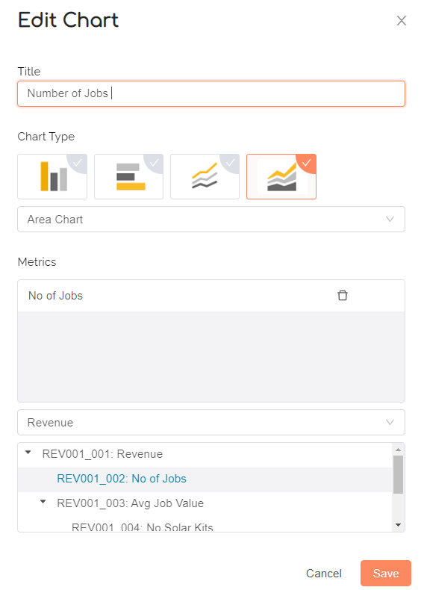
Step 1e | Add and customise Revenue Trend ($) chart as shown and save  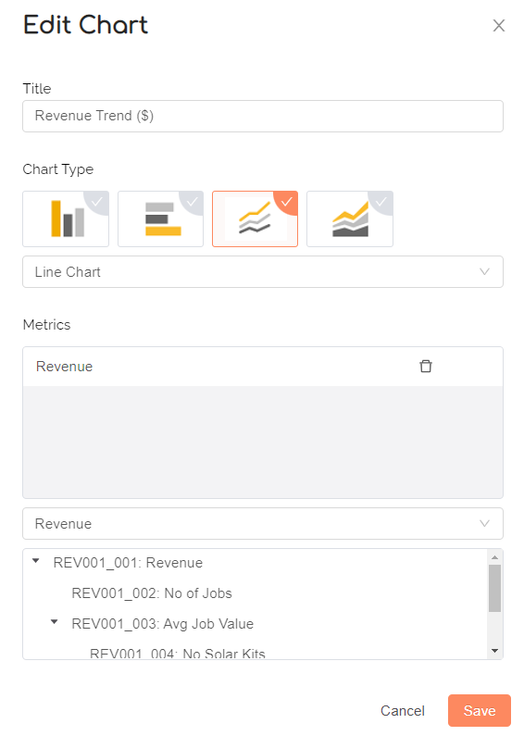
TIPS | TIP: You can use the settings icon to control number of dashboard tiles per row  TIP: You can choose metrics from another model using the model dropdown
Save | Save and view your dashboards  Switch to Dashboard View to see your time series dashboard  