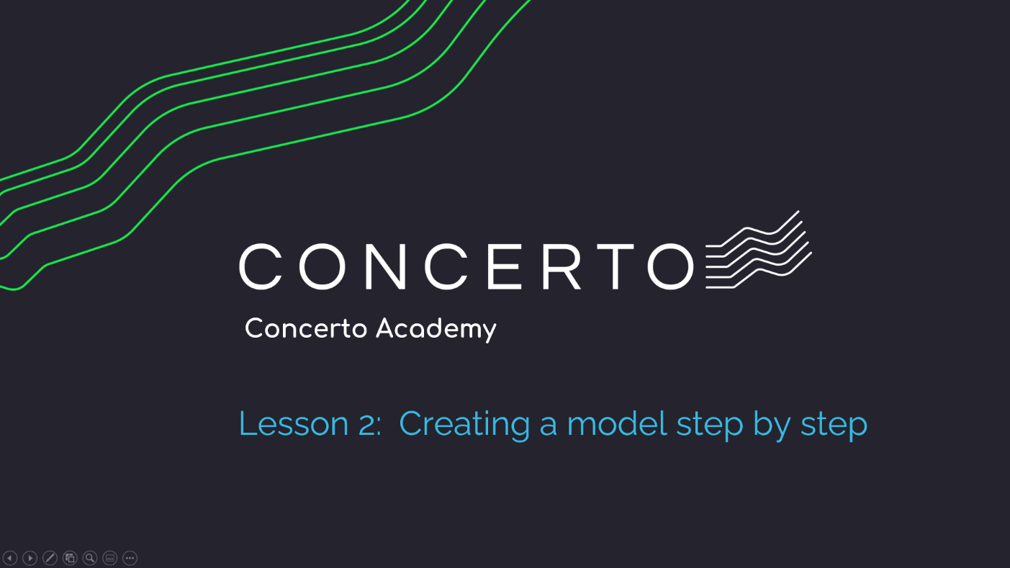

Table of Contents
Introduction 5
Concerto Academy Overview 5
Lesson 2: Creating a scorecard step by step 7
Overview 7
Lesson Objectives 7
Lesson Outcome 7
Part 1: Creating a scorecard step by step 8
Video 8
Step by Step 9

Introduction

Concerto Academy Overview
The Concerto Academy is designed to cover Concerto basics and provide simple step-by-step exercises to get you going fast.

Concerto Academy lessons cover the following:

- Concerto Overview & Case Study

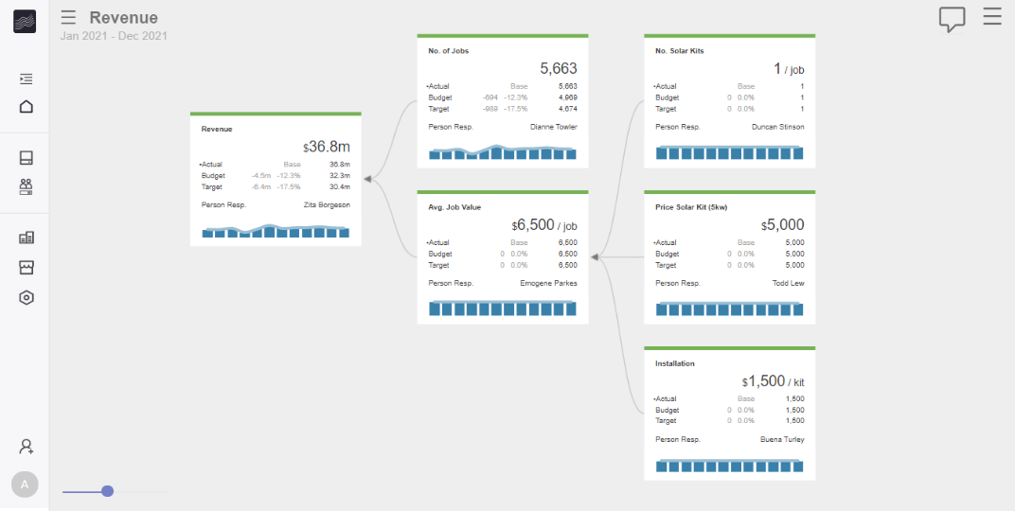
- Creating a model step by step
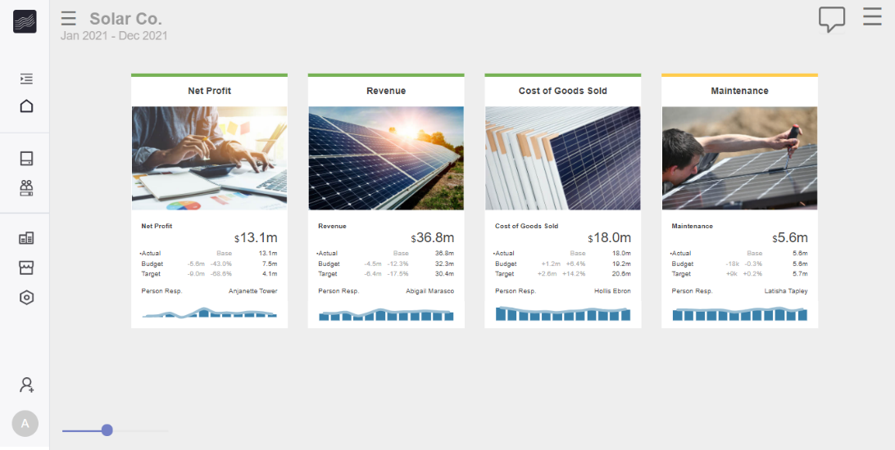
- Creating a scorecard step by step
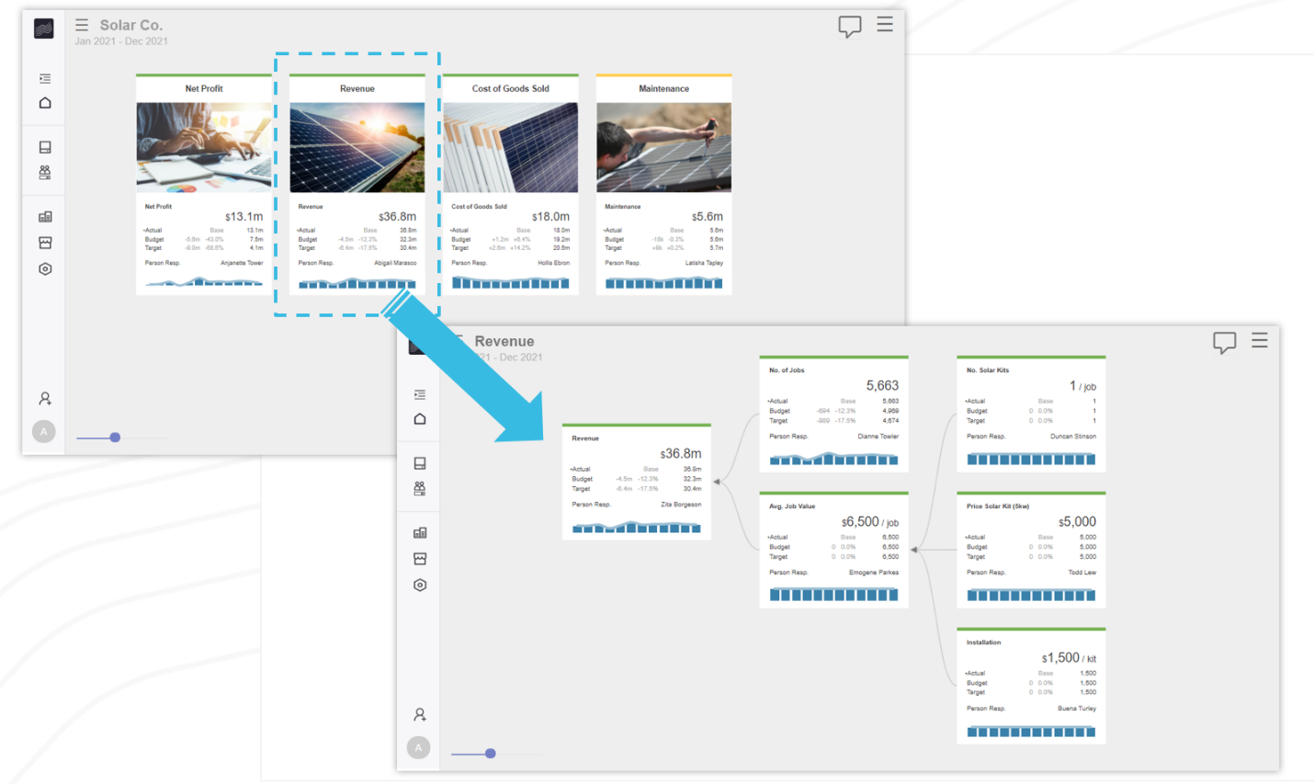
- Linking scorecards and models

Lesson 2: Creating a scorecard step by step

Overview

Lesson Objectives
This lesson covers creating a simple scorecard step-by-step.
- Part 1: Creating a scorecard step by step

Lesson Outcome
Creation of the scorecard below.

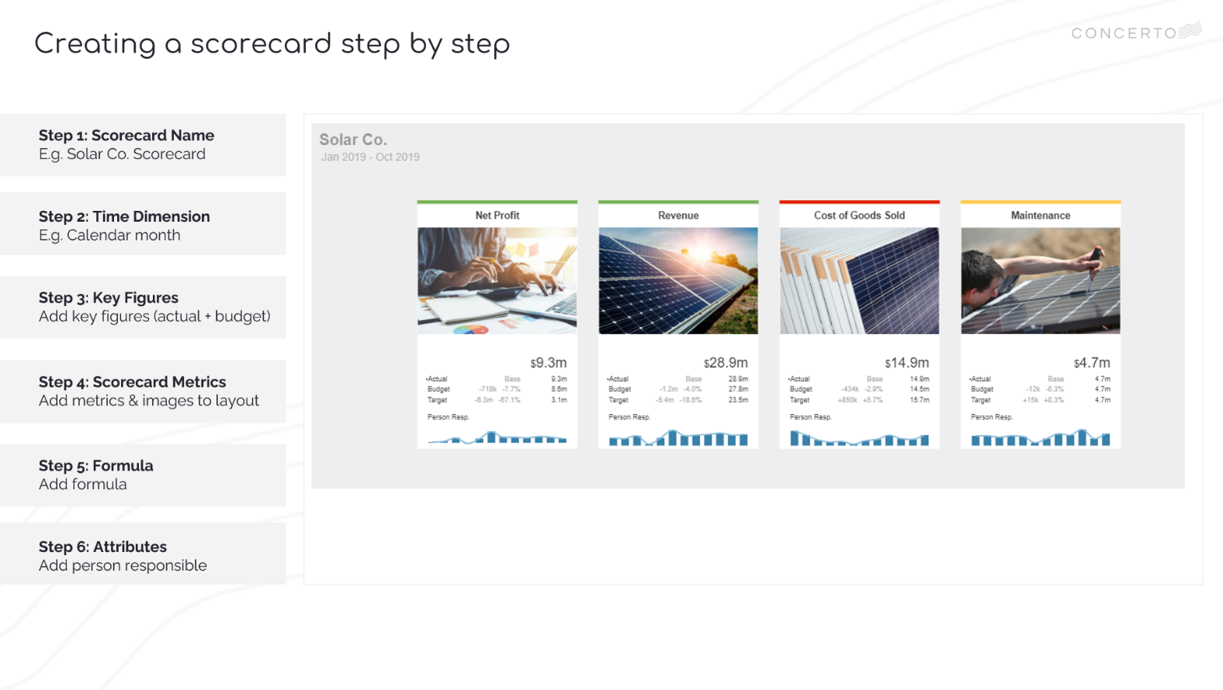
Part 1: Creating a scorecard step by step

Video
- VIDEO: Lesson 2 – Creating a scorecard step by step
- VIDEO TIMESTAMP: 0.18

Step by Step
Step 1 | Scorecard Name  From recent, edit My Solar Co  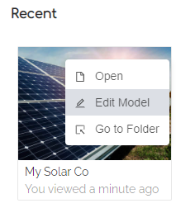  Switch to edit mode  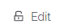  Click New to create your scorecard  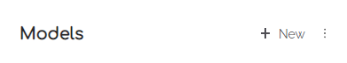  Set Model Name: My Scorecard  Set Model Type: Scorecard  Click Create  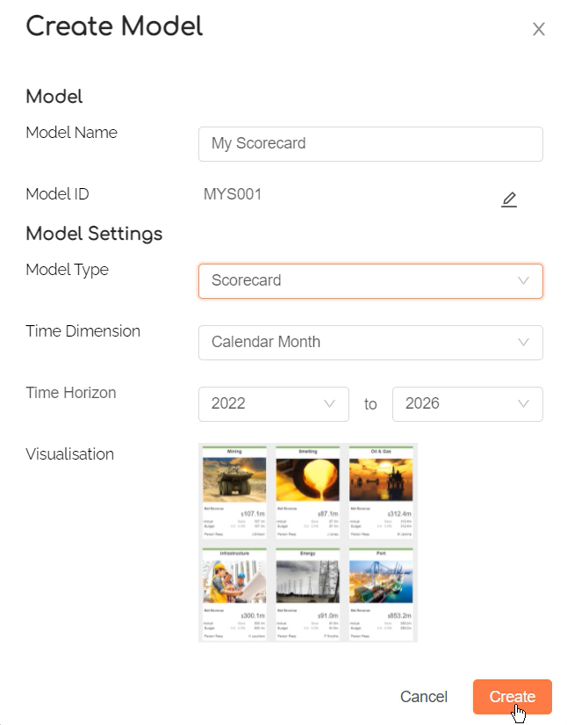
Step 2 | Time Dimension  Check Time Dimension is set to Calendar Month  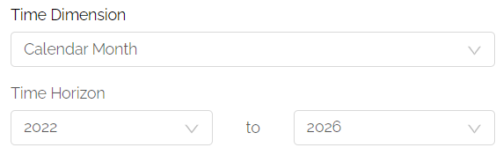
Step 3 | Key Figures  Check Key Figure settings are as shown below  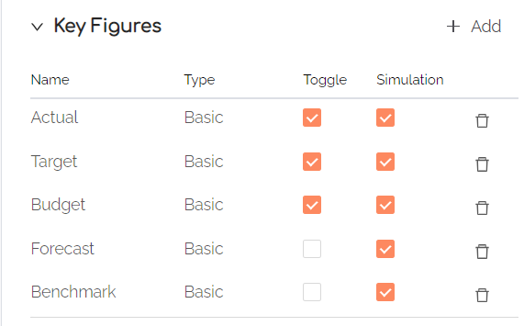  Check Toolbar Tile & Spark settings are as shown below:  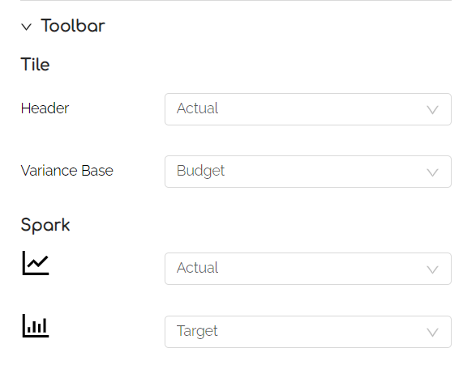  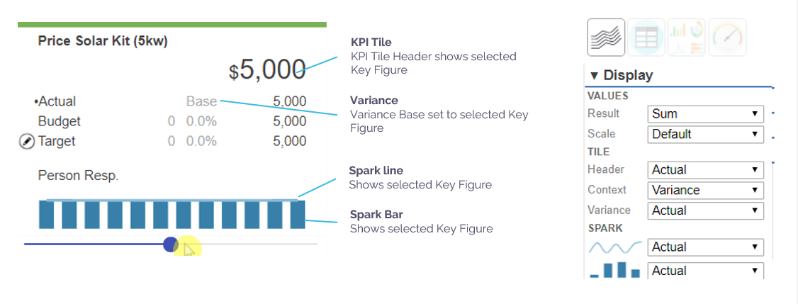

Step 4 | Model Metrics & Layout  The following steps cover adding Solar Co scorecard metrics step by step.  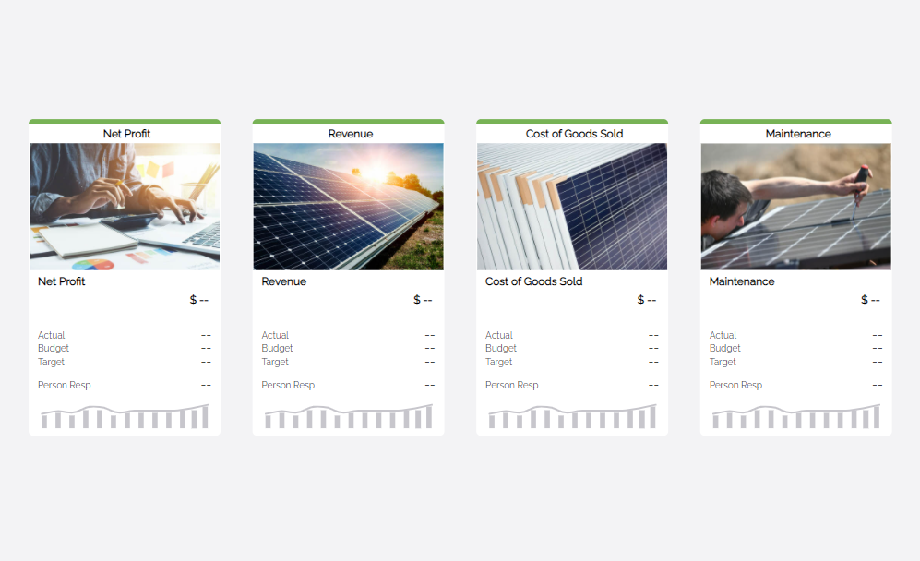  TIP: Add Metrics directly on canvas using + button  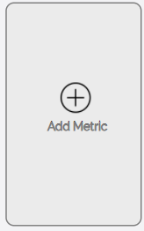  Set properties for each metric as shown below
Step 4a | Add Net Profit tile  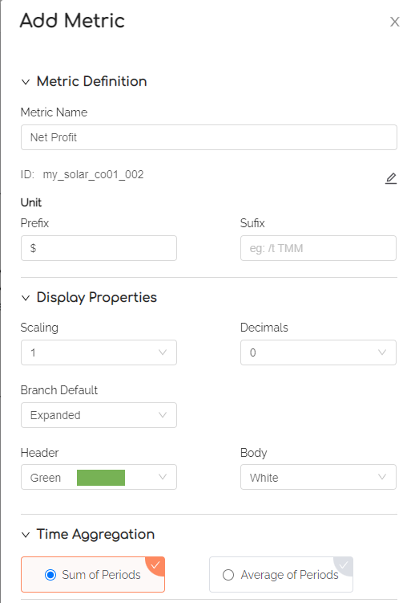  Select image 01 Net Profit from My Drive > Training > Solar Co > Images  
Step 4b | Add Revenue tile  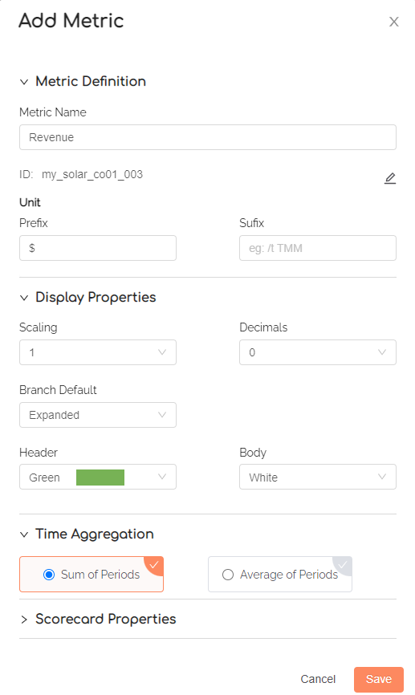  Select image 02 Revenue from My Drive > Training > Solar Co > Images  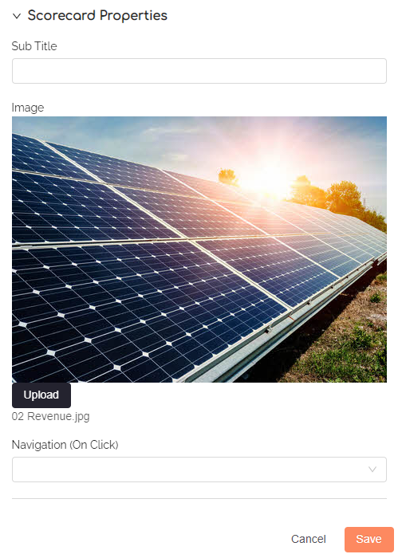
Step 4c | Add Cost of Goods Sold tile  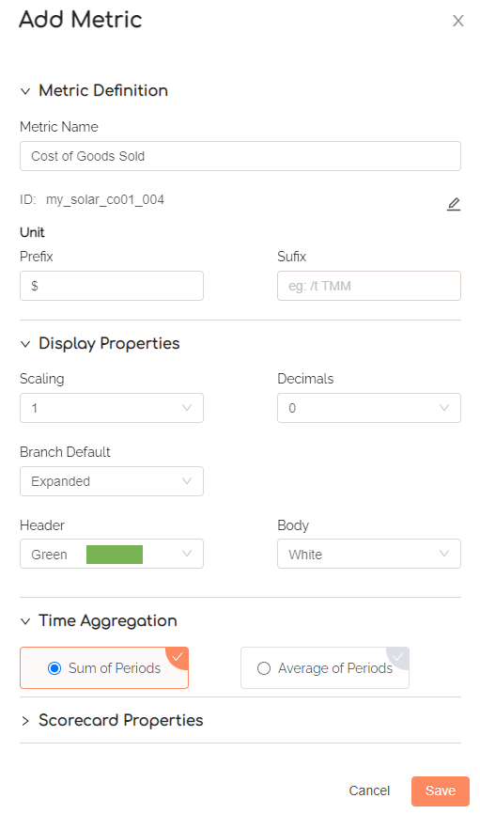  Select image 03 Cost of Goods Sold in My Drive >Training > Solar Co > Images  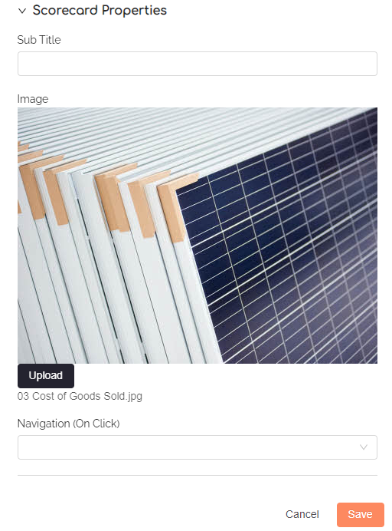
Step 4d | Add Maintanence tile  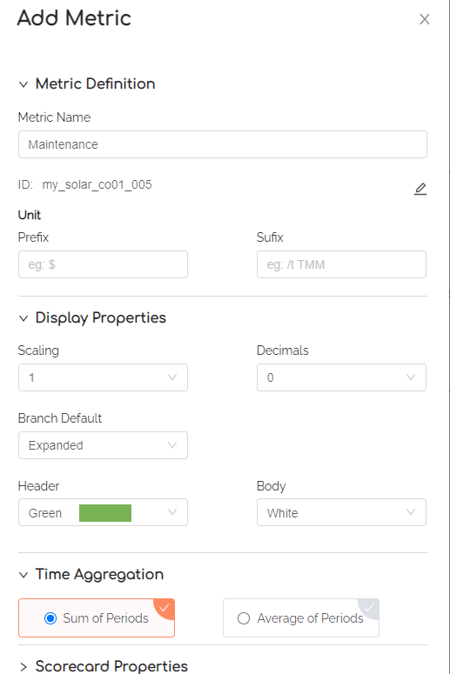  Select image 04 Maintenance in My Drive >Training > Solar Co > Images  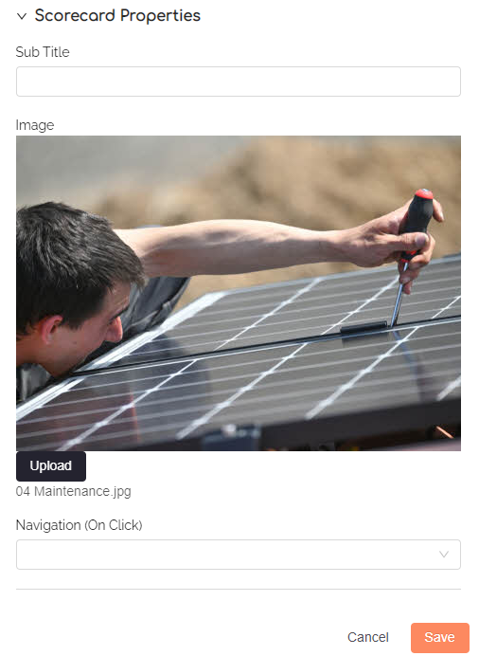
Step 5 | Attributes  Create Person Resp as an attribute, and add a name of person responsible for each metric  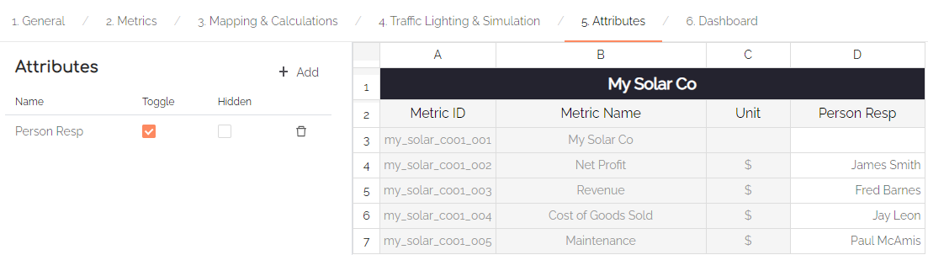
Step 6 | Set Scorecard to open first  Save your model    To ensure scorecard opens first, click My Solar Co document    Drag My Solar Co Scorecard to top  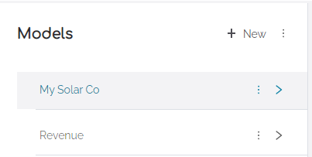  TIP: Ensure sure you are in change mode.
Step 7 | Save and View your model  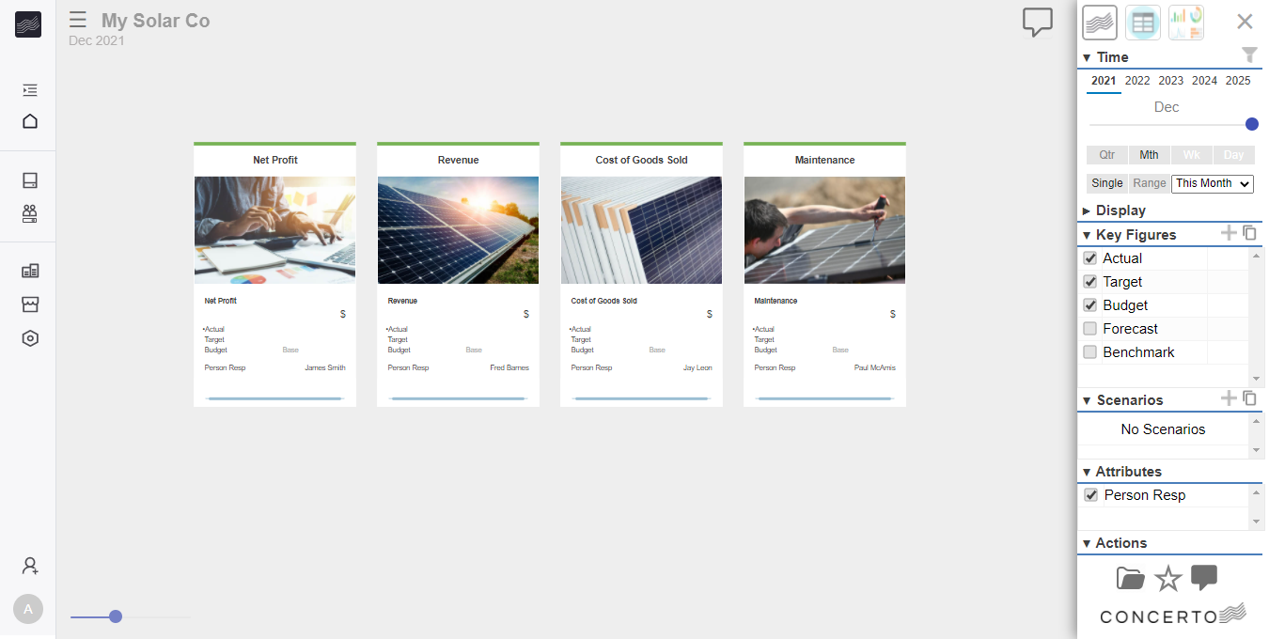  TIP: In next lesson, we will link our scorecard to our Revenue model, including formula to populate the Revenue scorecard tile.

