

Table of Contents

Lesson 3: Linking scorecards and models 5
Overview 5
Lesson Objectives 5
Lesson Outcome 5
Part 1: Linking scorecards and models: formula 7
Video 7
Step by Step 8
Part 2: Linking scorecards and models: navigation 11
Video 11
Step by Step 12

Lesson 3: Linking scorecards and models

Overview

Lesson Objectives
This lesson covers creating a simple model step-by-step.
- Part 1: Linking scorecards and models – formula
- Part 2: Linking scorecards and models – navigation

Lesson Outcome
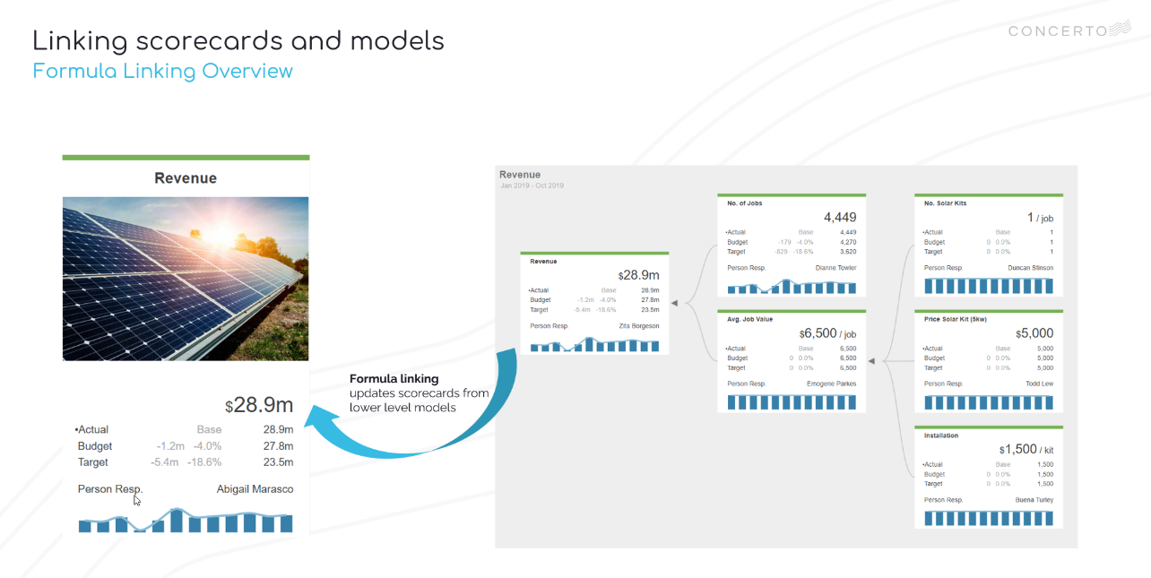
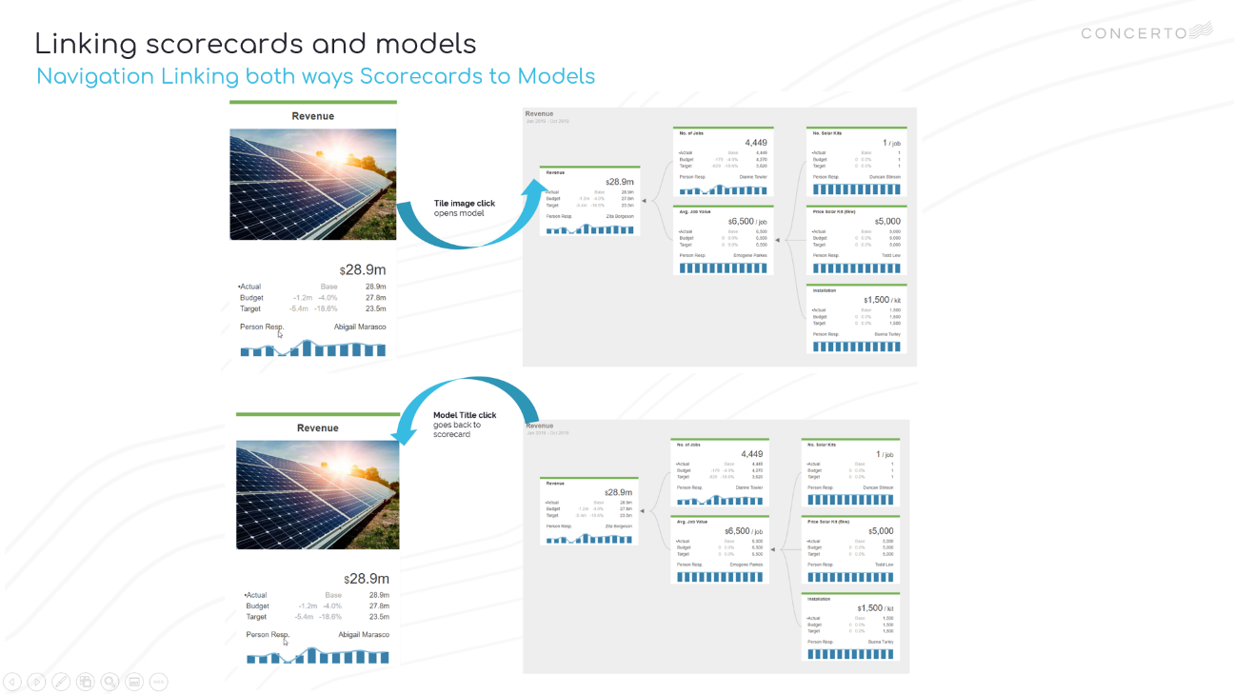
Successful linking of scorecard and model with formula and navigation.

Part 1: Linking scorecards and models: formula

Video
- VIDEO: Lesson 2 – Linking scorecards and models step by step
- VIDEO TIMESTAMP: 0.10

Step by Step
Step 1 | Scorecard formula linking to model  From recent, edit My Solar Co  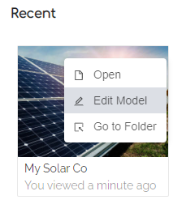  Open My Solar Co scorecard and switch to Edit Mode    Go to Mapping & Calculation tab and select Revenue  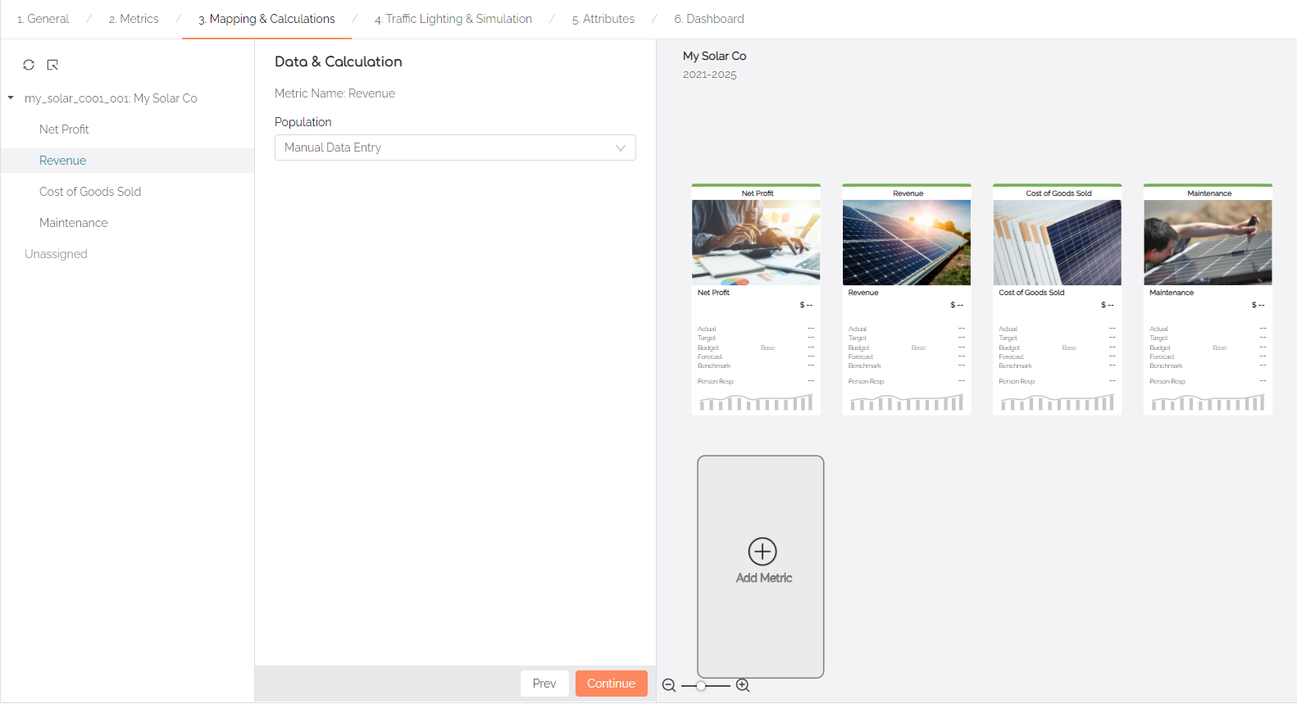  Choose Calculation using Advanced Formula Build  Select the revenue model under model linkage  Double-click Revenue to add to the formula  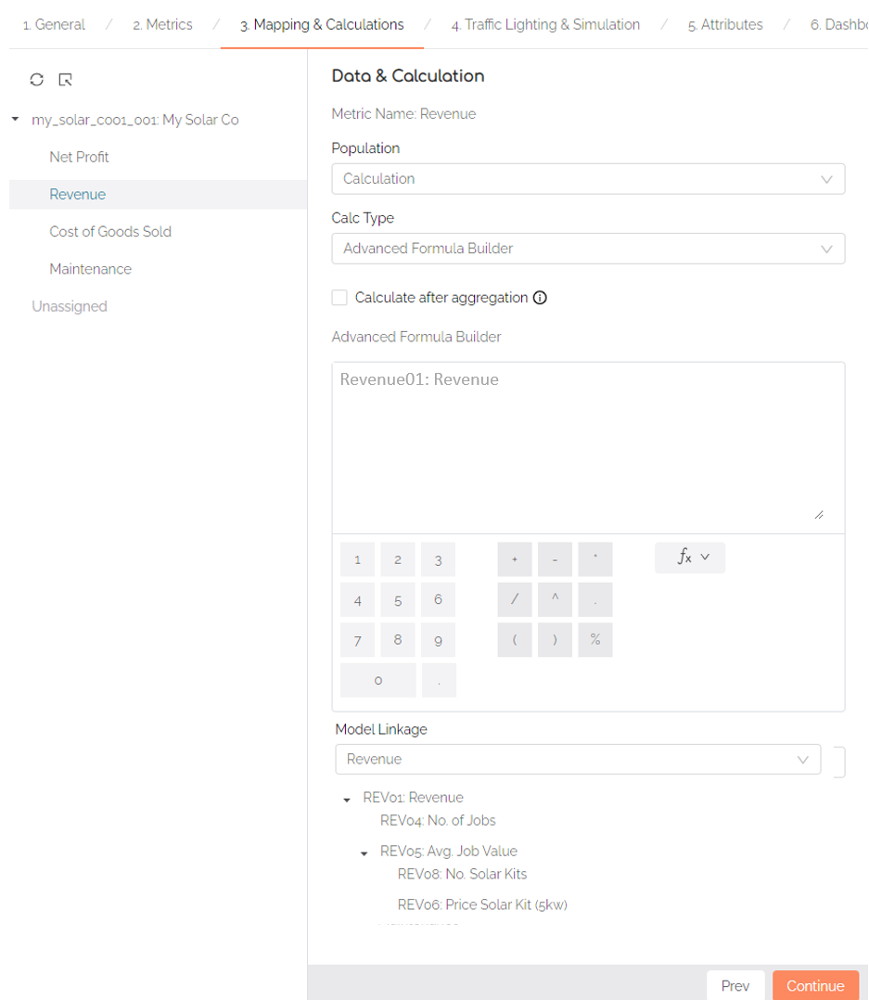
Save | Save and View your model  The Revenue tile is now being populated by the underlying Revenue model using formula linkage    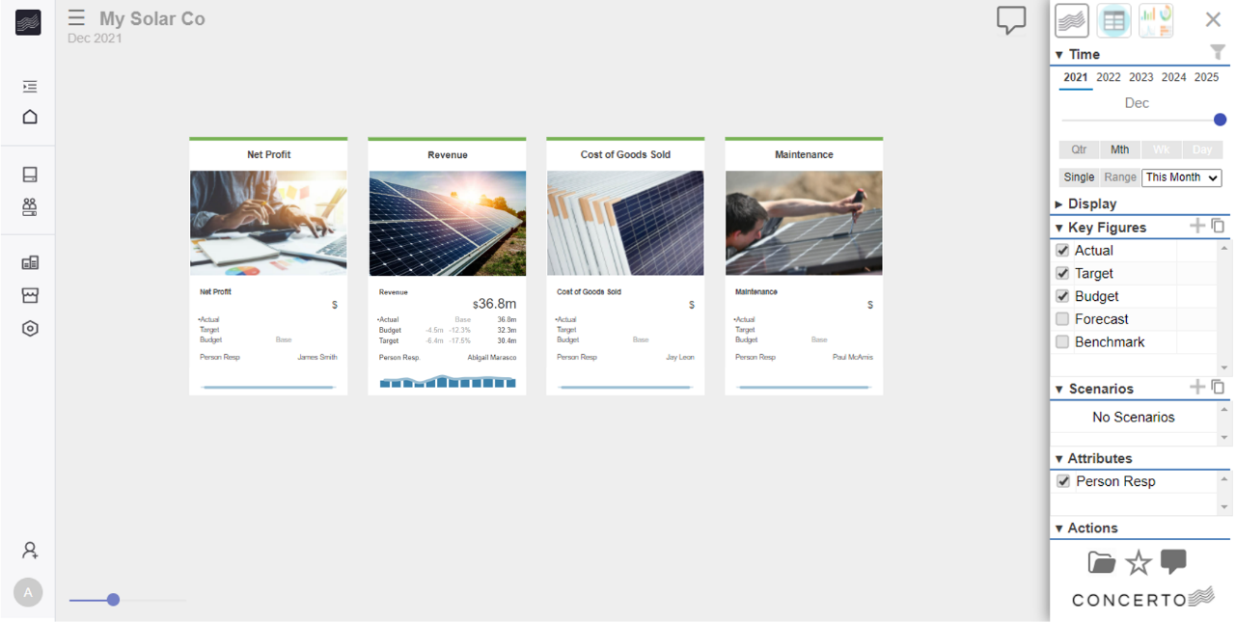

Part 2: Linking scorecards and models: navigation

Video
- VIDEO: Lesson 2 – Linking a scorecard and model step by step
- VIDEO TIMESTAMP: 2.23

Step by Step
Step 1 | Navigation linking: scorecard > model  From recent, edit My Solar Co  Open My Solar Co scorecard and switch to Edit Mode  Go to Metric tab and select Revenue  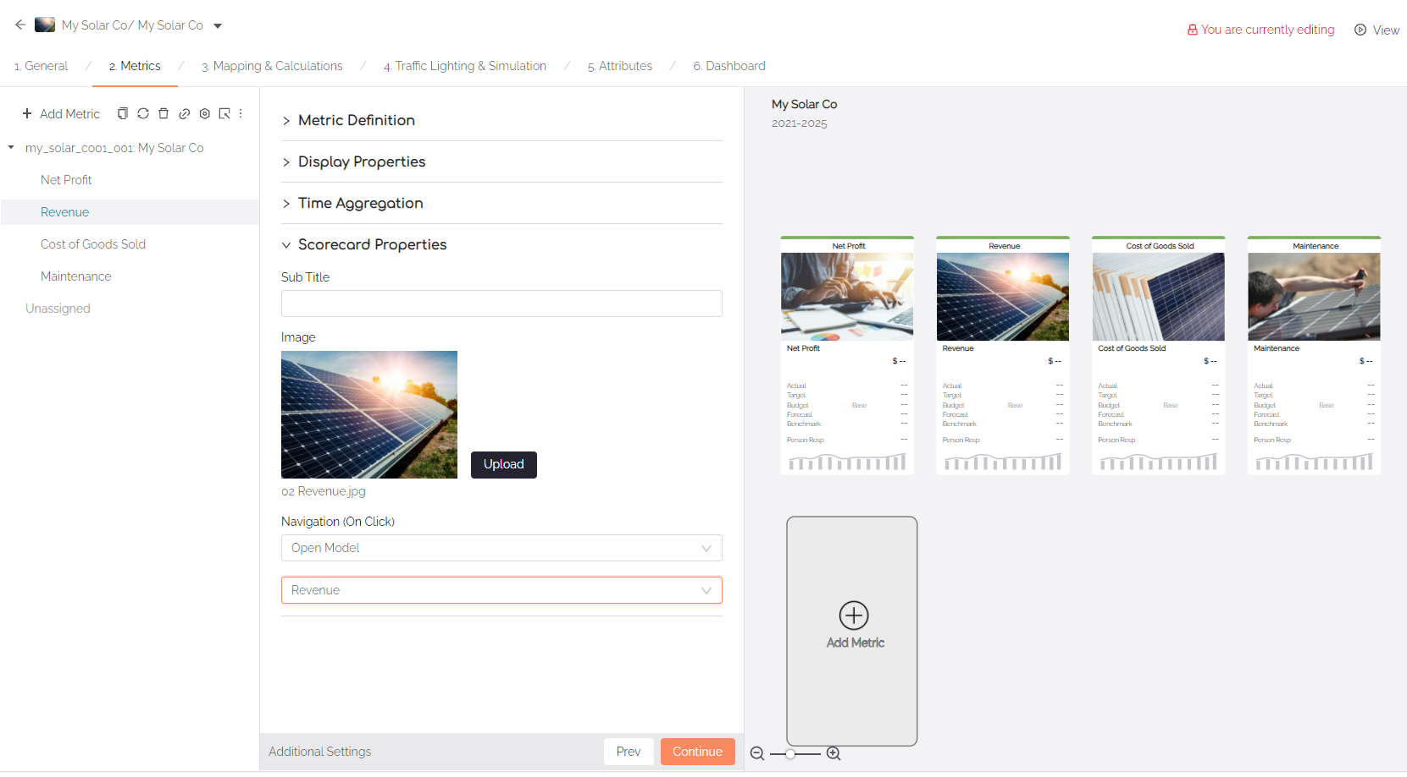  Under Scorecard Properties set Navigation On Click to open model Revenue  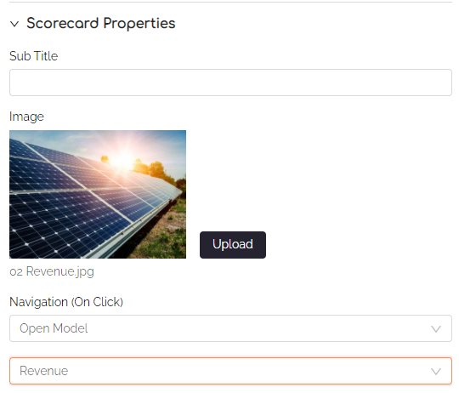  Save your model
Step 2 | Navigation linking: model > scorecard  Open Revenue model and switch to Edit Mode  Under General tab click Additional Settings  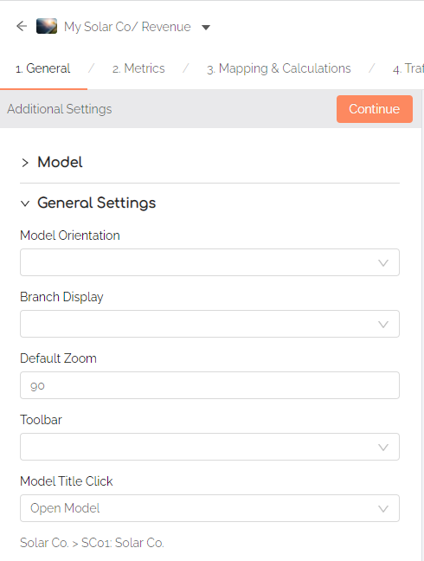  Under General Settings > Model Title Click set to Open Model  Set Open Model Target to Revenue model  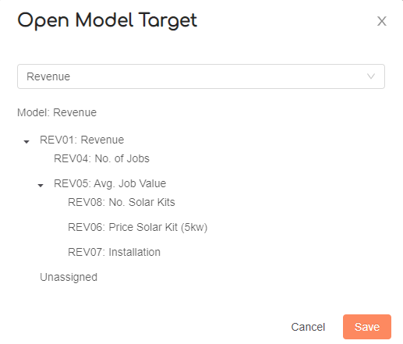
Save | Save and View your model  Verify the following:  - Scorecard Revenue tile navigates to Revenue model on image click  - Revenue Model navigates back to Scorecard on model title click

